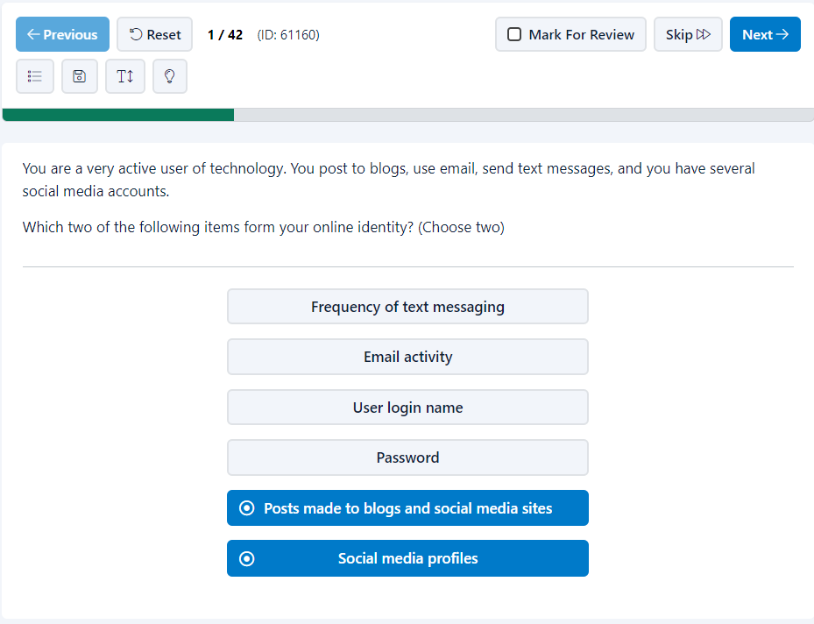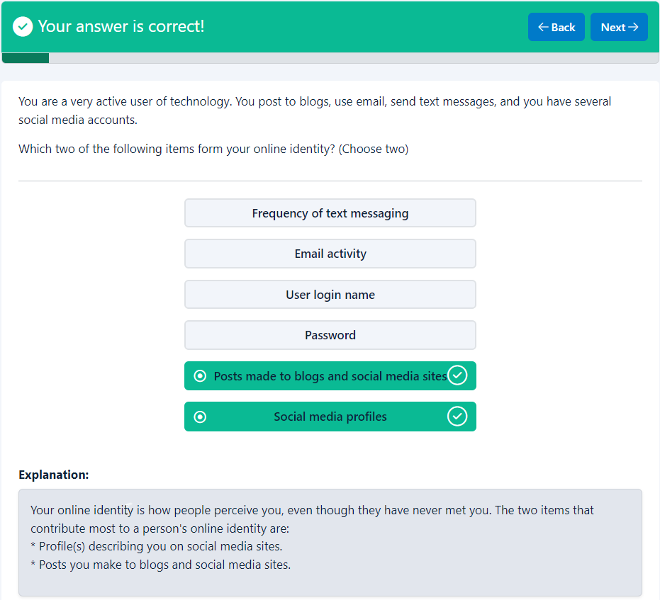
Your answer is correct!
Back Next
You are a very active user of technology. You post to blogs, use email, send text messages, and you have several social media accounts.
Which two of the following items form your online identity? (Choose two)

- Frequency of text messaging
- Email activity
- User login name
- Password
- Posts made to blogs and social media sites
- Social media profiles

Explanation
Explanation:
Your online identity is how people perceive you, even though they have never met you. The two items that contribute most to a person's online identity are:
* Profile(s) describing you on social media sites.
* Posts you make to blogs and social media sites.
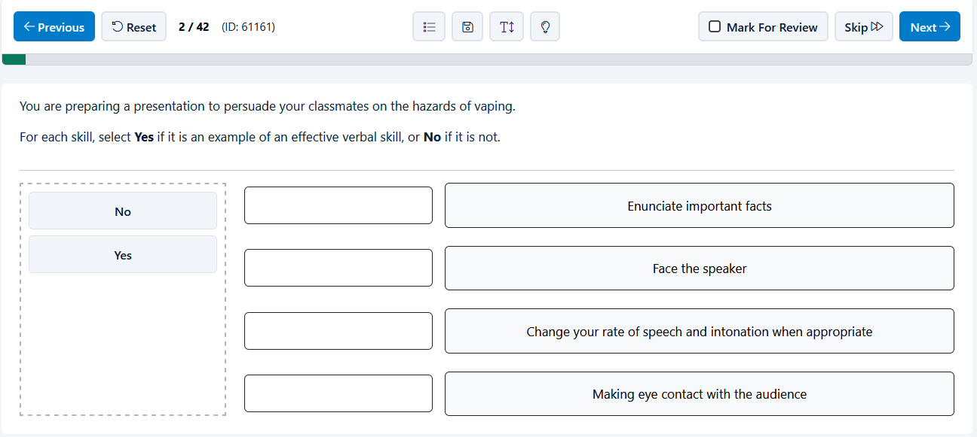
End of page
Top of Form
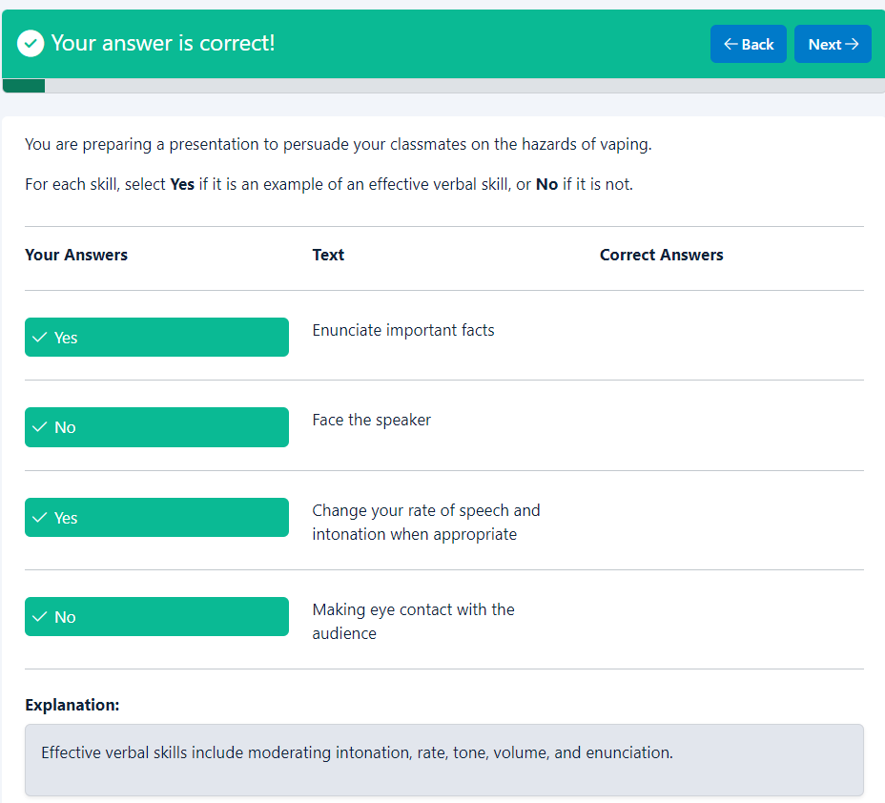
Your answer is correct!
BackNext
You are preparing a presentation to persuade your classmates on the hazards of vaping.
For each skill, select Yes if it is an example of an effective verbal skill, or No if it is not.

Your Answers
Text
Correct Answers

Yes
Enunciate important facts

No
Face the speaker

Yes
Change your rate of speech and intonation when appropriate

No
Making eye contact with the audience

Explanation
Explanation:
Effective verbal skills include moderating intonation, rate, tone, volume, and enunciation.

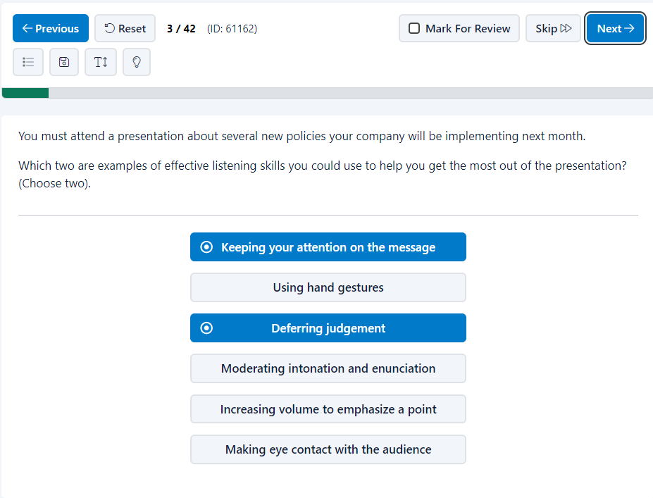
End of page
Top of Form
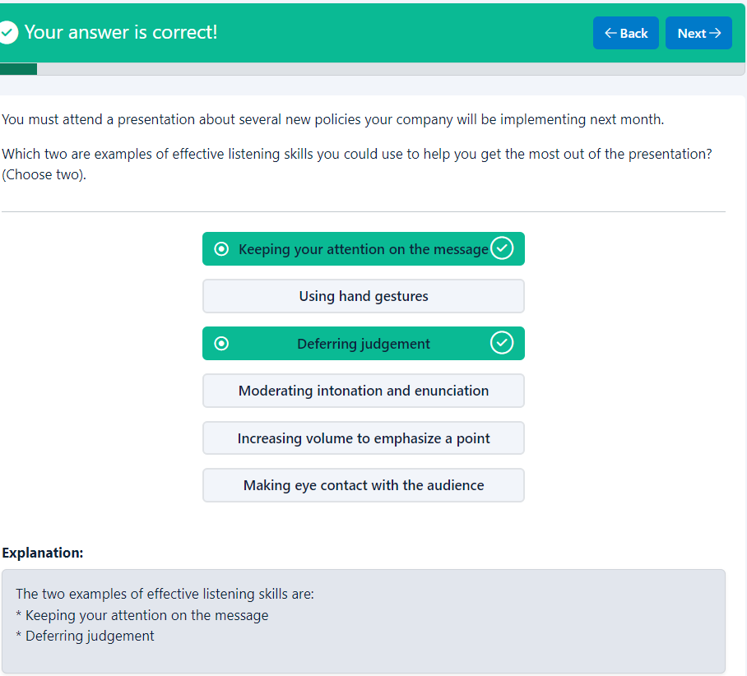Your answer is correct!
Back Next
You must attend a presentation about several new policies your company will be implementing next month.
Which two are examples of effective listening skills you could use to help you get the most out of the presentation? (Choose two).

- Keeping your attention on the message
- Using hand gestures
- Deferring judgement
- Moderating intonation and enunciation
- Increasing volume to emphasize a point
- Making eye contact with the audience

Explanation
Explanation:
The two examples of effective listening skills are:
* Keeping your attention on the message
* Deferring judgement

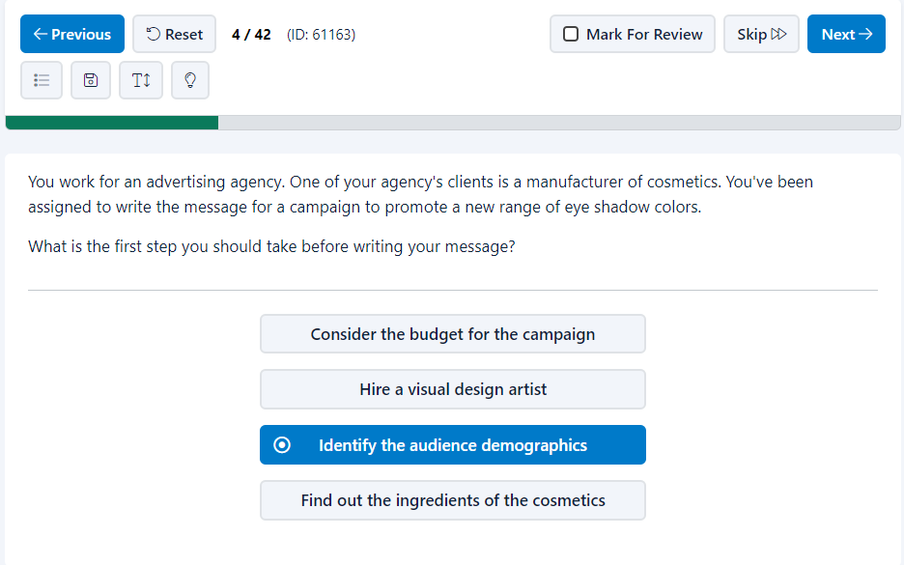
End of page
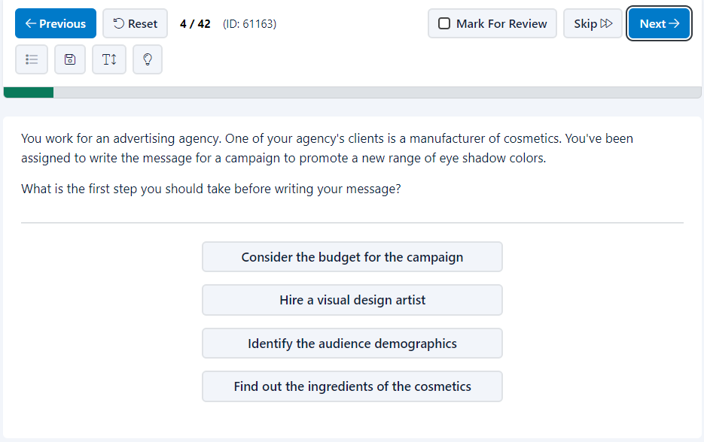
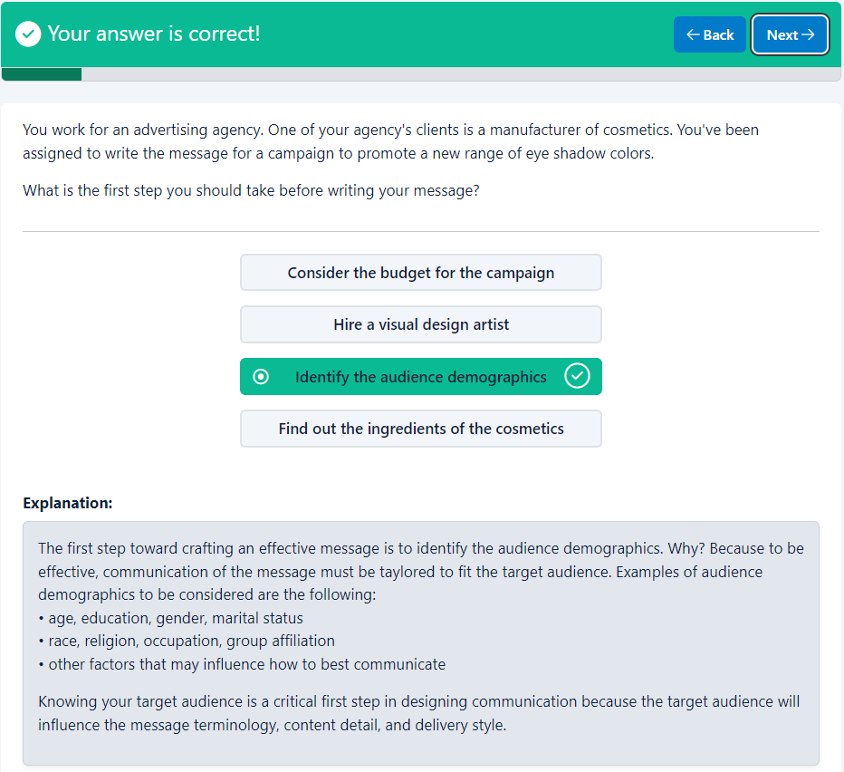
Top of Form
Your answer is correct!
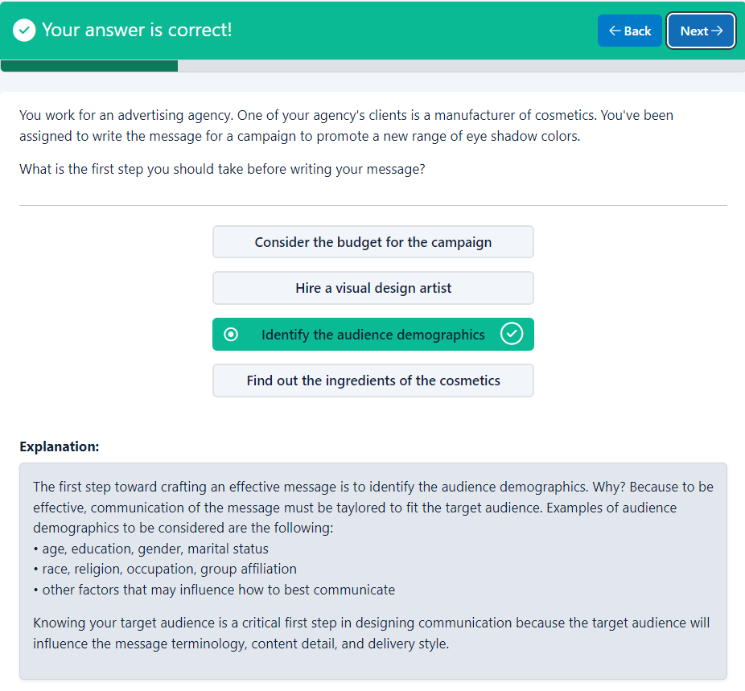
BackNext
You work for an advertising agency. One of your agency's clients is a manufacturer of cosmetics. You've been assigned to write the message for a campaign to promote a new range of eye shadow colors.
What is the first step you should take before writing your message?

- Consider the budget for the campaign
- Hire a visual design artist
- Identify the audience demographics
- Find out the ingredients of the cosmetics

Explanation
Explanation:
The first step toward crafting an effective message is to identify the audience demographics. Why? Because to be effective, communication of the message must be taylored to fit the target audience. Examples of audience demographics to be considered are the following:
• age, education, gender, marital status
• race, religion, occupation, group affiliation
• other factors that may influence how to best communicate
Knowing your target audience is a critical first step in designing communication because the target audience will influence the message terminology, content detail, and delivery style.

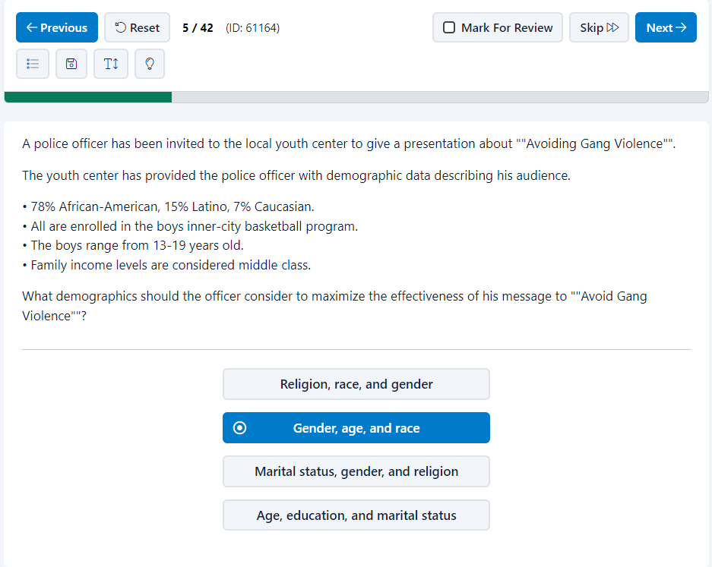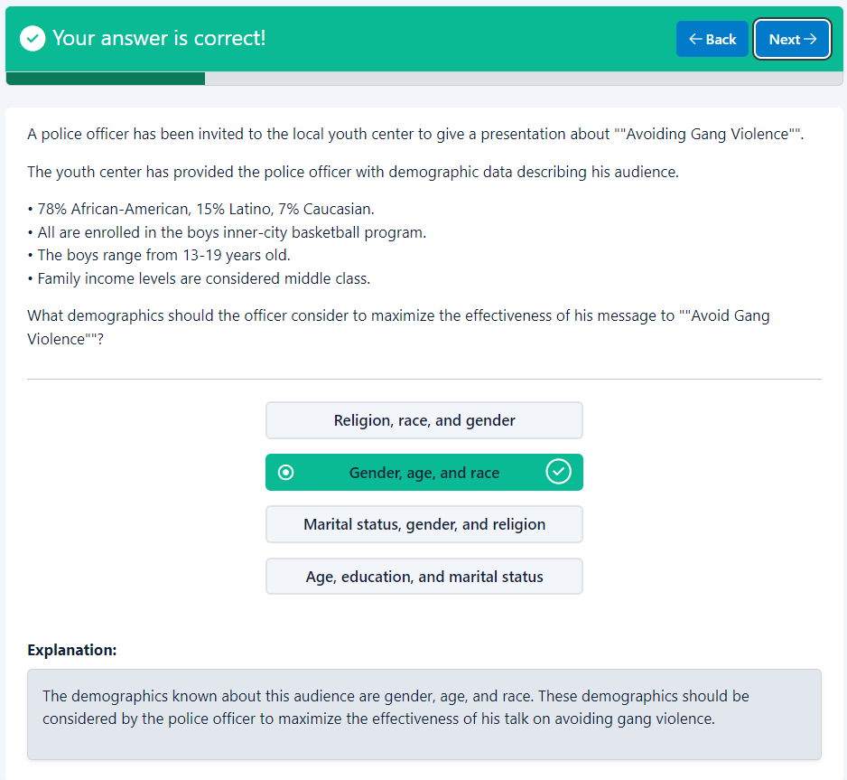
End of page
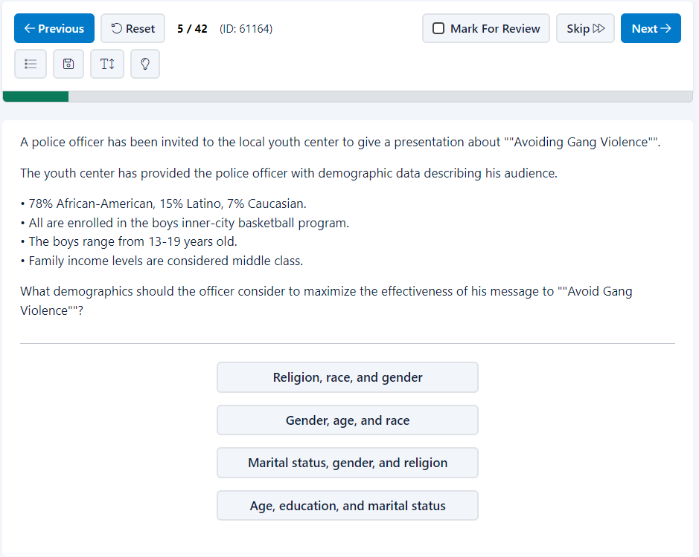
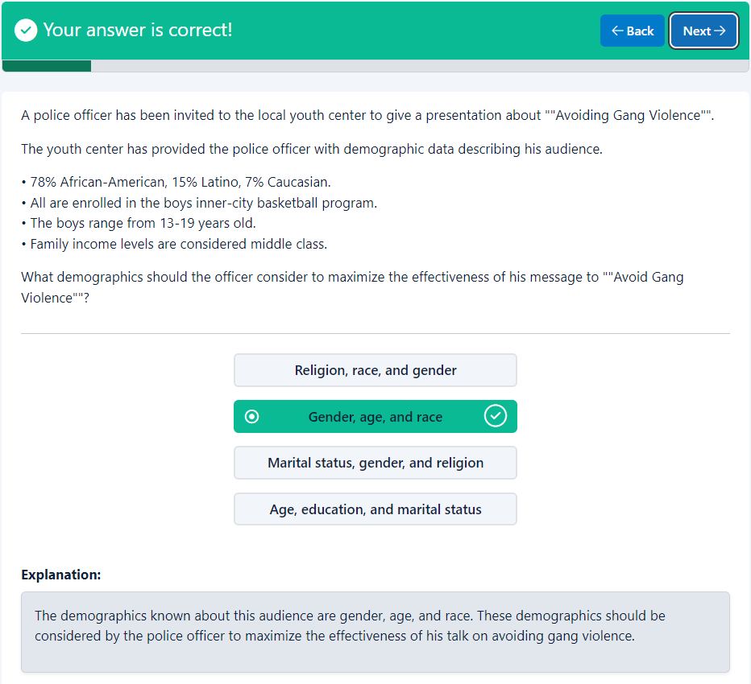
Top of Form
Your answer is correct!
BackNext
A police officer has been invited to the local youth center to give a presentation about ""Avoiding Gang Violence"".
The youth center has provided the police officer with demographic data describing his audience.
• 78% African-American, 15% Latino, 7% Caucasian.
• All are enrolled in the boys inner-city basketball program.
• The boys range from 13-19 years old.
• Family income levels are considered middle class.
What demographics should the officer consider to maximize the effectiveness of his message to ""Avoid Gang Violence""?

- Religion, race, and gender
- Gender, age, and race
- Marital status, gender, and religion
- Age, education, and marital status

Explanation
Explanation:
The demographics known about this audience are gender, age, and race. These demographics should be considered by the police officer to maximize the effectiveness of his talk on avoiding gang violence.

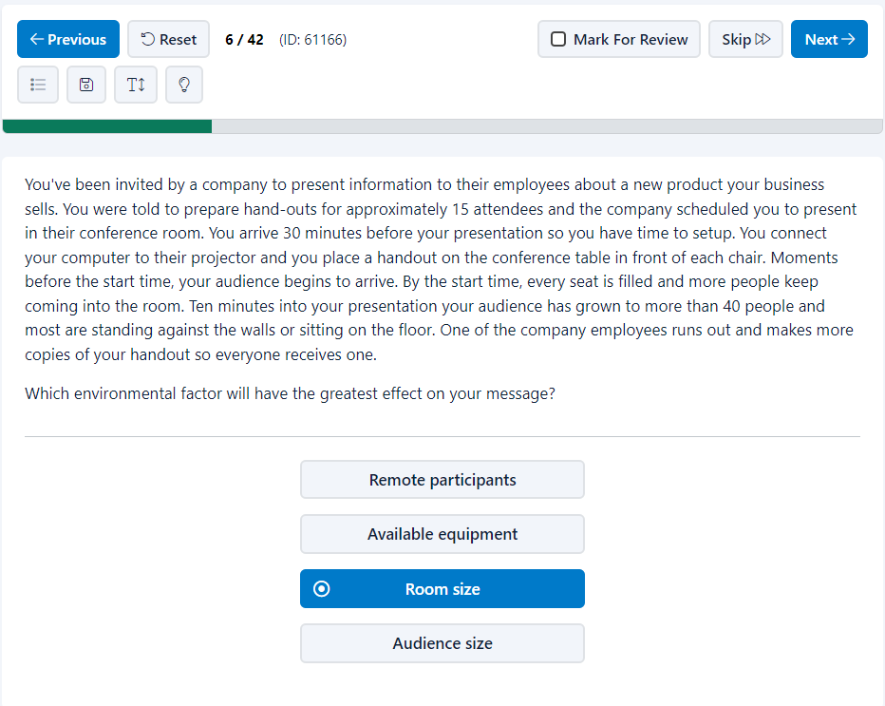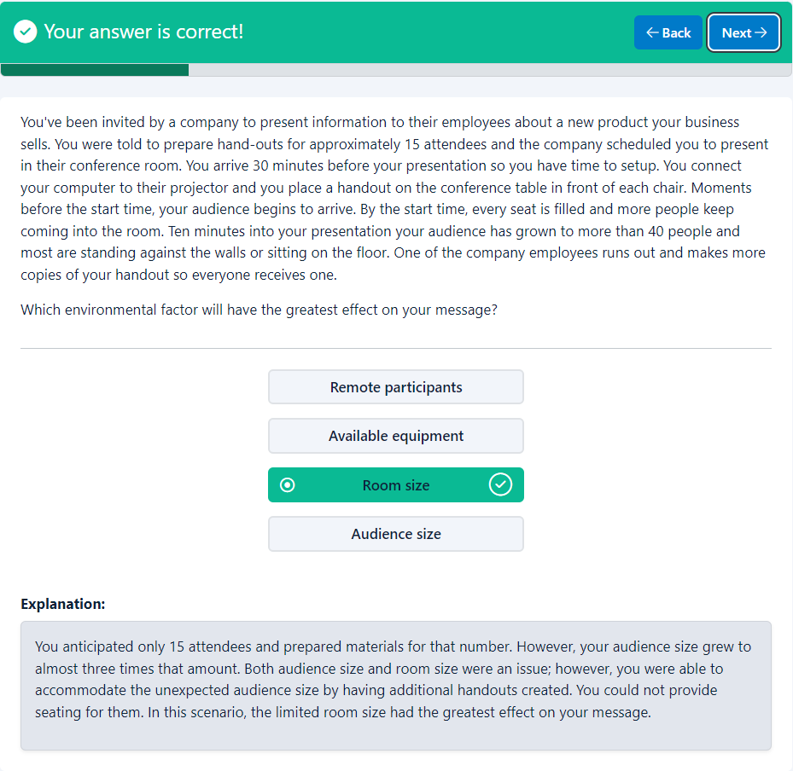
End of page
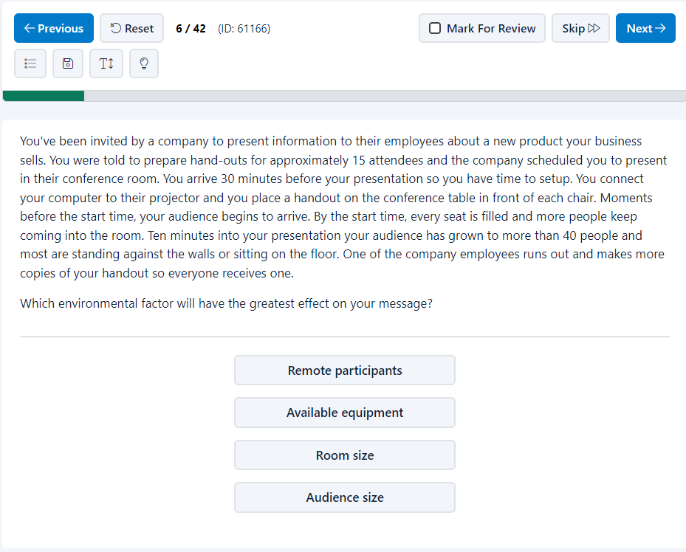
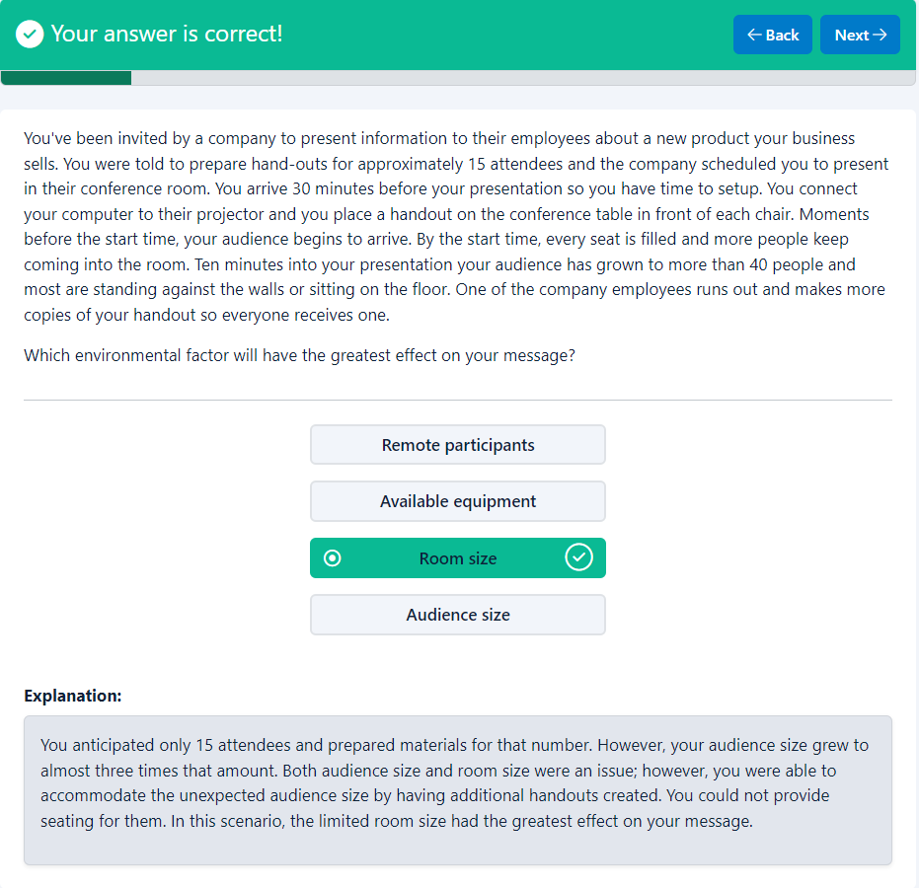
Top of Form
Your answer is correct!
BackNext
You've been invited by a company to present information to their employees about a new product your business sells. You were told to prepare hand-outs for approximately 15 attendees and the company scheduled you to present in their conference room. You arrive 30 minutes before your presentation so you have time to setup. You connect your computer to their projector and you place a handout on the conference table in front of each chair. Moments before the start time, your audience begins to arrive. By the start time, every seat is filled and more people keep coming into the room. Ten minutes into your presentation your audience has grown to more than 40 people and most are standing against the walls or sitting on the floor. One of the company employees runs out and makes more copies of your handout so everyone receives one.
Which environmental factor will have the greatest effect on your message?

- Remote participants
- Available equipment
- Room size
- Audience size

Explanation
Explanation:
You anticipated only 15 attendees and prepared materials for that number. However, your audience size grew to almost three times that amount. Both audience size and room size were an issue; however, you were able to accommodate the unexpected audience size by having additional handouts created. You could not provide seating for them. In this scenario, the limited room size had the greatest effect on your message.

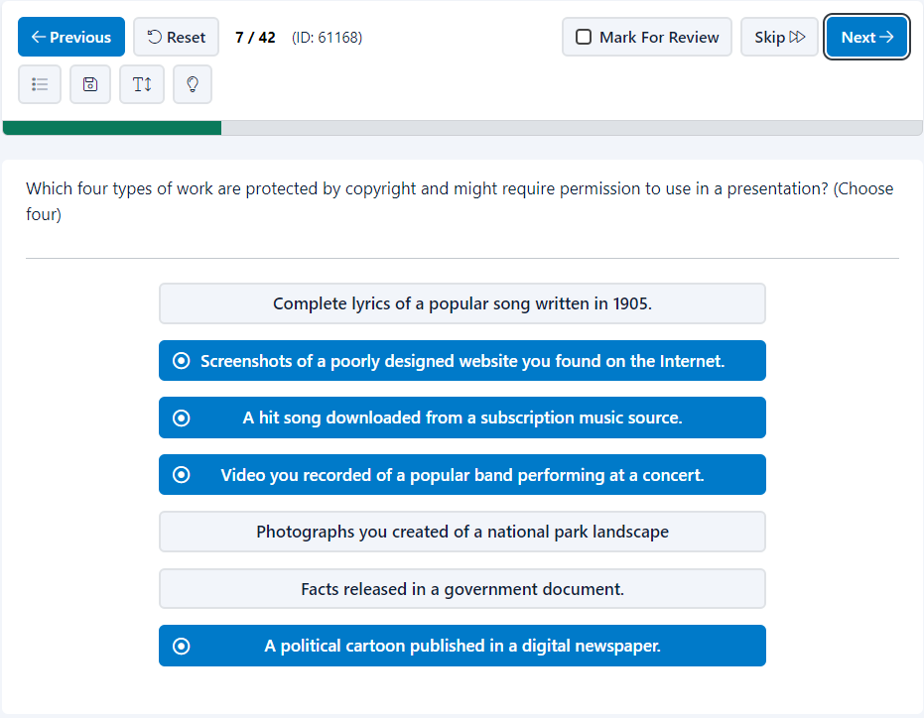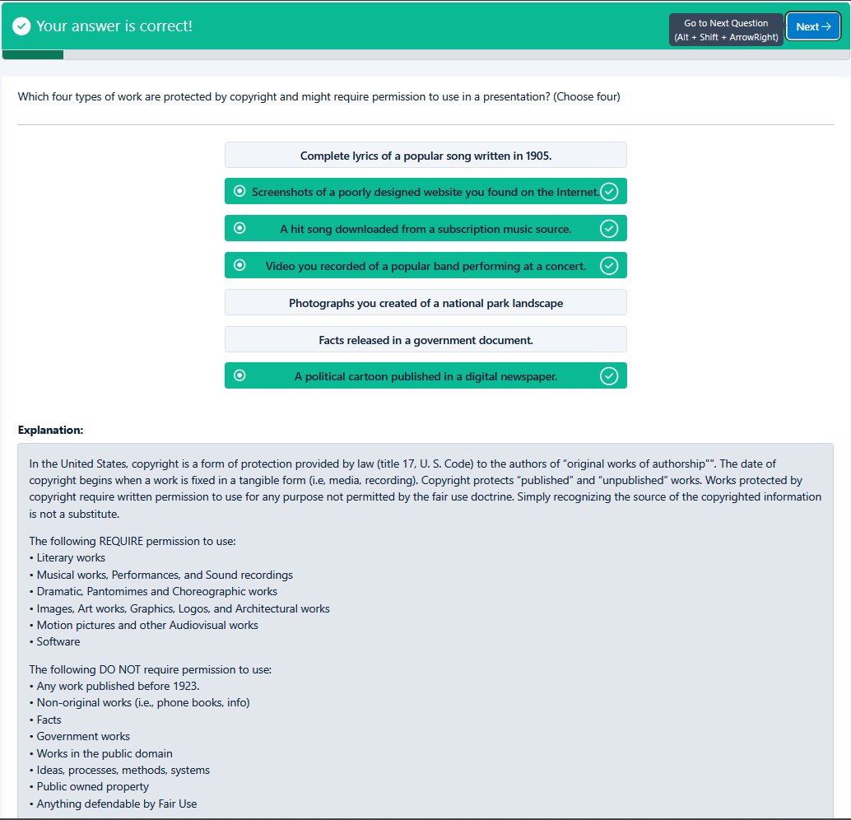
End of page
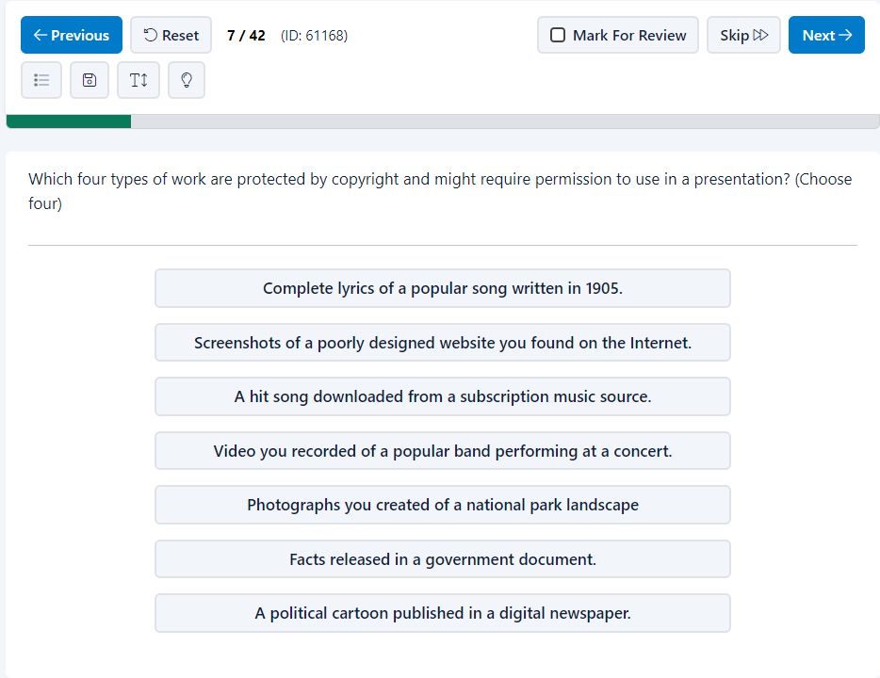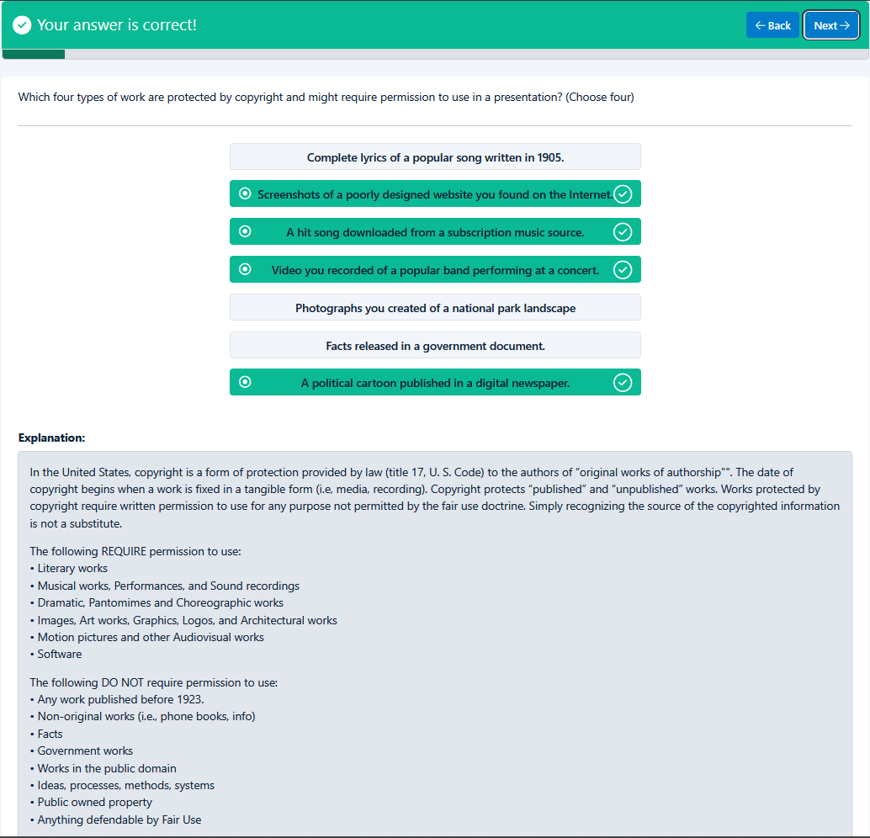
Top of Form
Your answer is correct!
BackNext
Which four types of work are protected by copyright and might require permission to use in a presentation? (Choose four)

- Complete lyrics of a popular song written in 1905.
- Screenshots of a poorly designed website you found on the Internet.
- A hit song downloaded from a subscription music source.
- Video you recorded of a popular band performing at a concert.
- Photographs you created of a national park landscape
- Facts released in a government document.
- A political cartoon published in a digital newspaper.

Explanation
Explanation:
In the United States, copyright is a form of protection provided by law (title 17, U. S. Code) to the authors of “original works of authorship"". The date of copyright begins when a work is fixed in a tangible form (i.e, media, recording). Copyright protects “published” and “unpublished” works. Works protected by copyright require written permission to use for any purpose not permitted by the fair use doctrine. Simply recognizing the source of the copyrighted information is not a substitute.
The following REQUIRE permission to use:
• Literary works
• Musical works, Performances, and Sound recordings
• Dramatic, Pantomimes and Choreographic works
• Images, Art works, Graphics, Logos, and Architectural works
• Motion pictures and other Audiovisual works
• Software
The following DO NOT require permission to use:
• Any work published before 1923.
• Non-original works (i.e., phone books, info)
• Facts
• Government works
• Works in the public domain
• Ideas, processes, methods, systems
• Public owned property
• Anything defendable by Fair Use

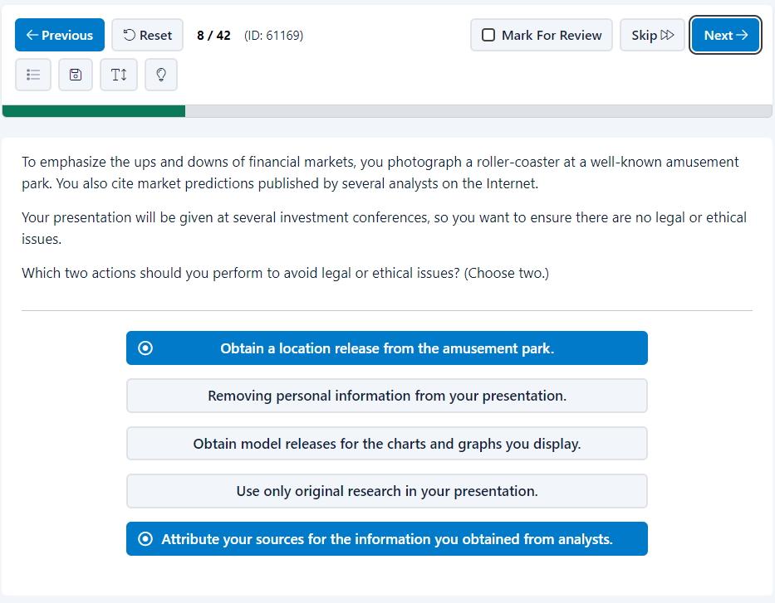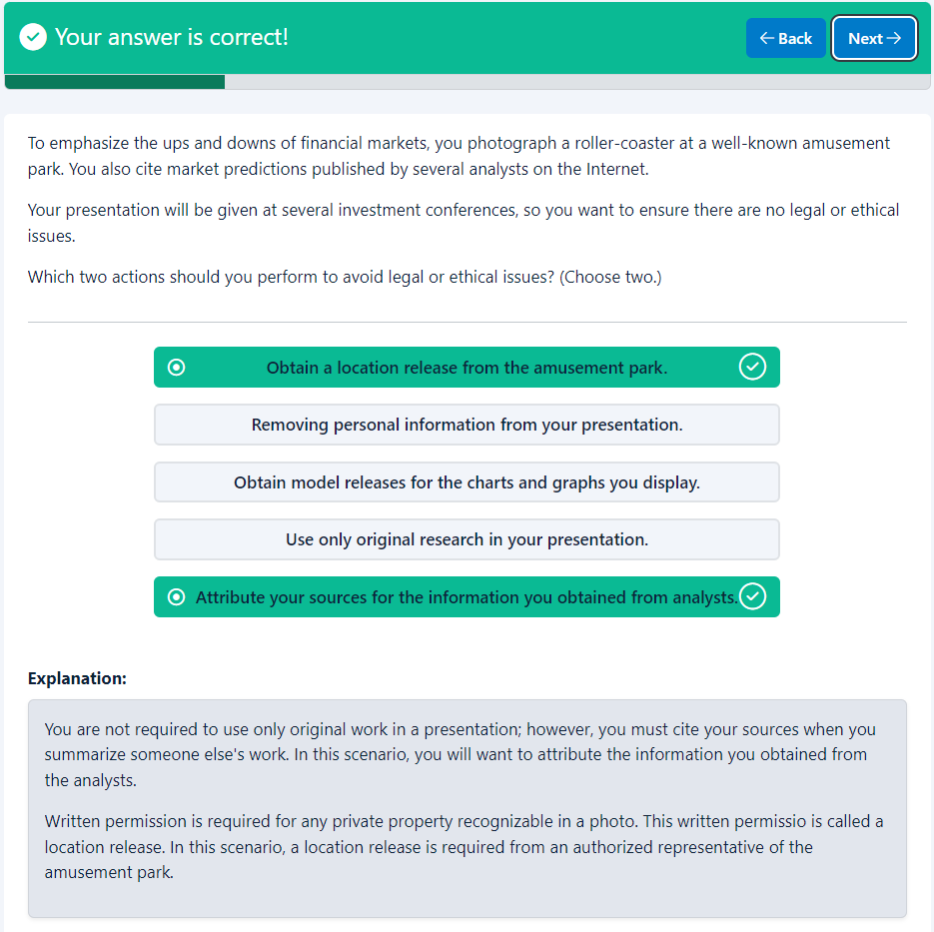
End of page
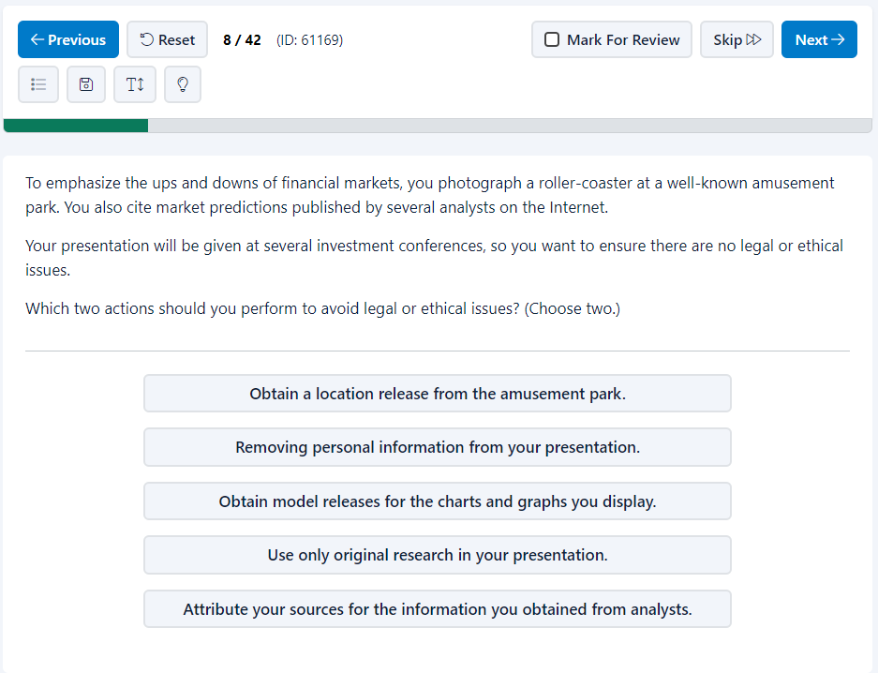
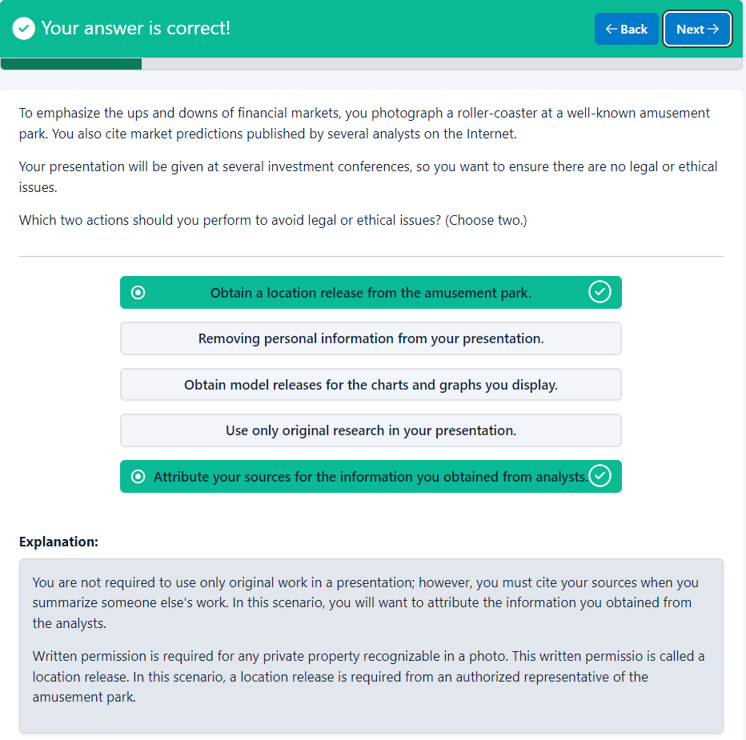
Top of Form
Your answer is correct!
BackNext
To emphasize the ups and downs of financial markets, you photograph a roller-coaster at a well-known amusement park. You also cite market predictions published by several analysts on the Internet.
Your presentation will be given at several investment conferences, so you want to ensure there are no legal or ethical issues.
Which two actions should you perform to avoid legal or ethical issues? (Choose two.)

Explanation
Explanation:
You are not required to use only original work in a presentation; however, you must cite your sources when you summarize someone else's work. In this scenario, you will want to attribute the information you obtained from the analysts.
Written permission is required for any private property recognizable in a photo. This written permissio is called a location release. In this scenario, a location release is required from an authorized representative of the amusement park.

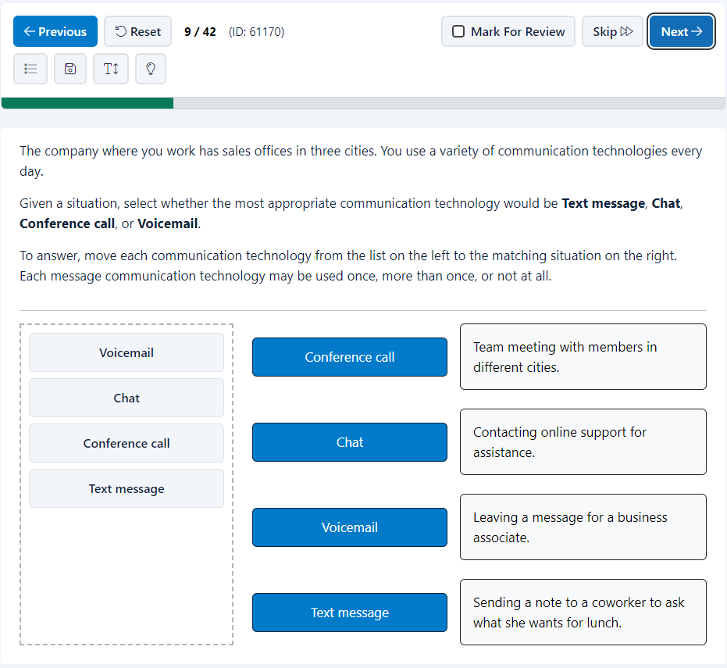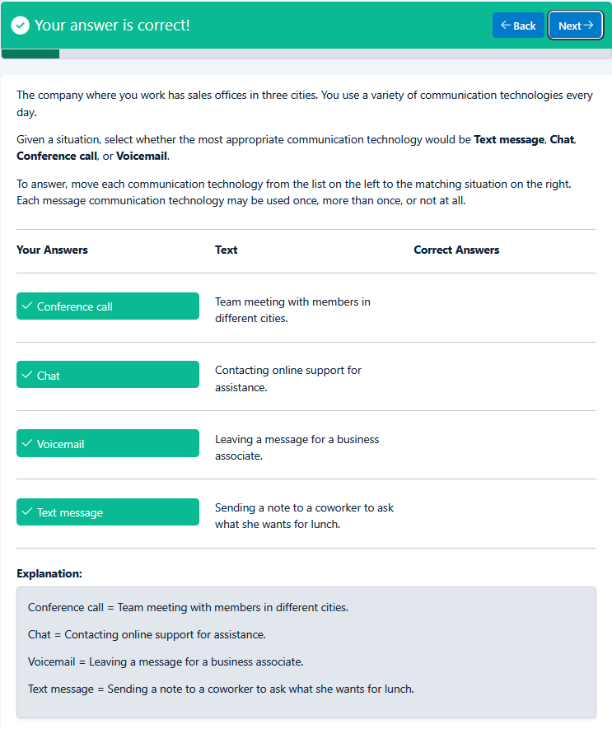
End of page
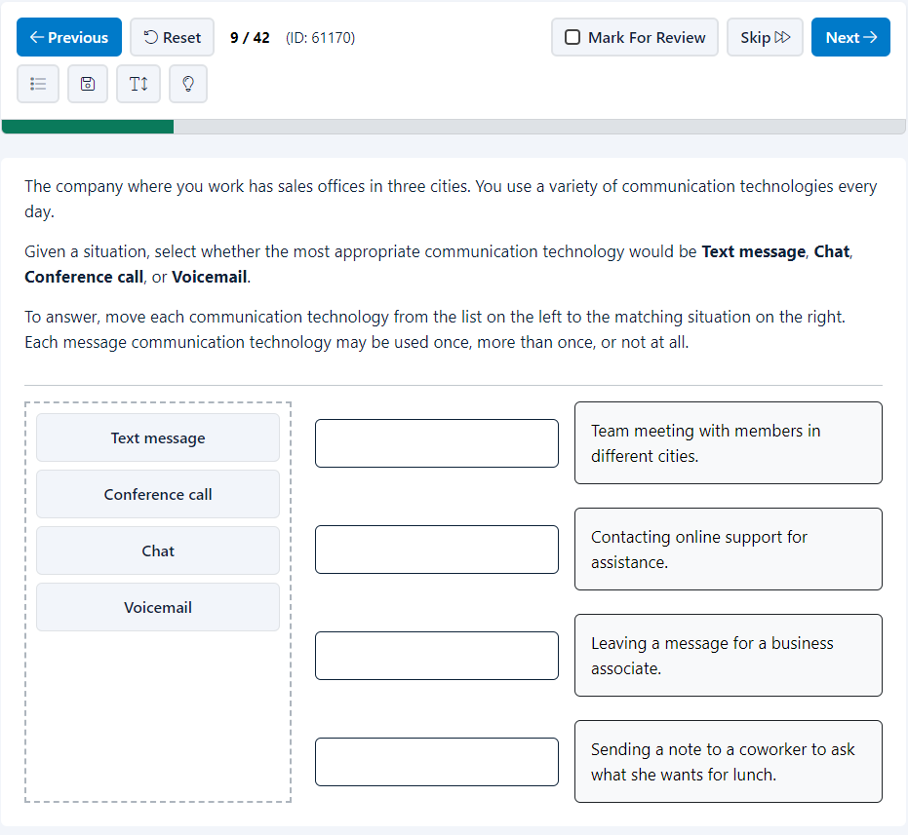
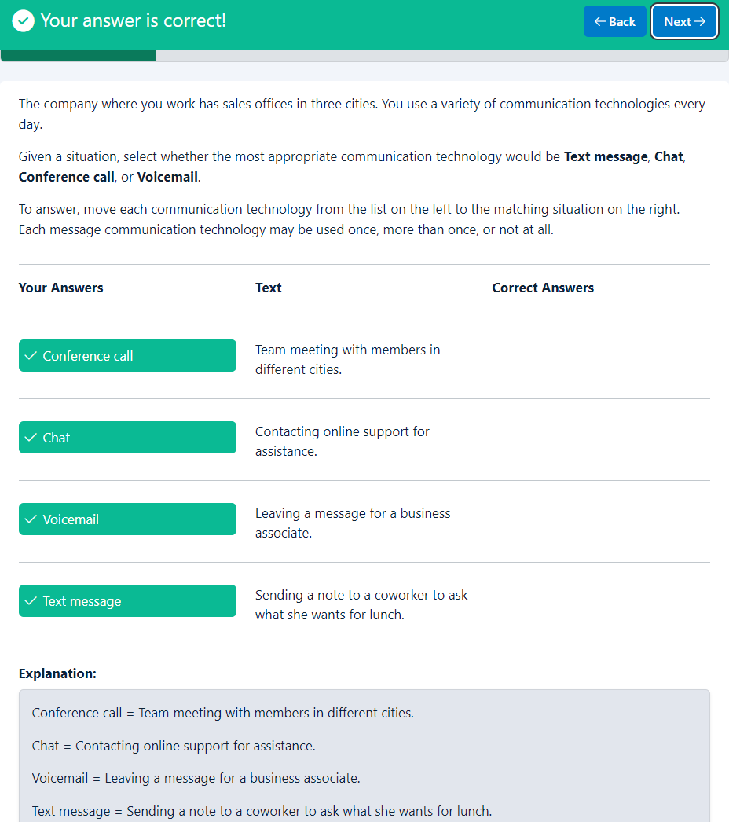
Top of Form
Your answer is correct!
BackNext
The company where you work has sales offices in three cities. You use a variety of communication technologies every day.
Given a situation, select whether the most appropriate communication technology would be Text message, Chat, Conference call, or Voicemail.
To answer, move each communication technology from the list on the left to the matching situation on the right. Each message communication technology may be used once, more than once, or not at all.

Your Answers
Text
Correct Answers

Conference call
Team meeting with members in different cities.

Chat
Contacting online support for assistance.

Voicemail
Leaving a message for a business associate.

Text message
Sending a note to a coworker to ask what she wants for lunch.

Explanation
Explanation:
Conference call = Team meeting with members in different cities.
Chat = Contacting online support for assistance.
Voicemail = Leaving a message for a business associate.
Text message = Sending a note to a coworker to ask what she wants for lunch.
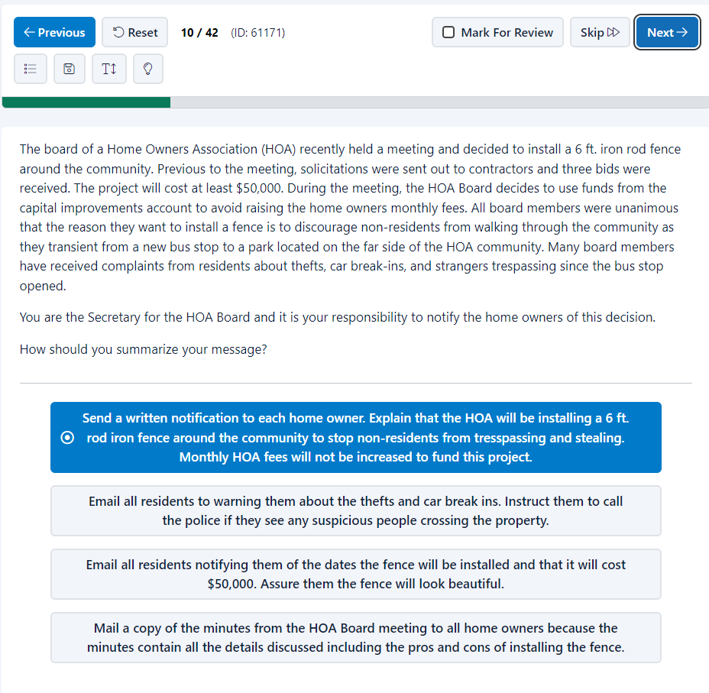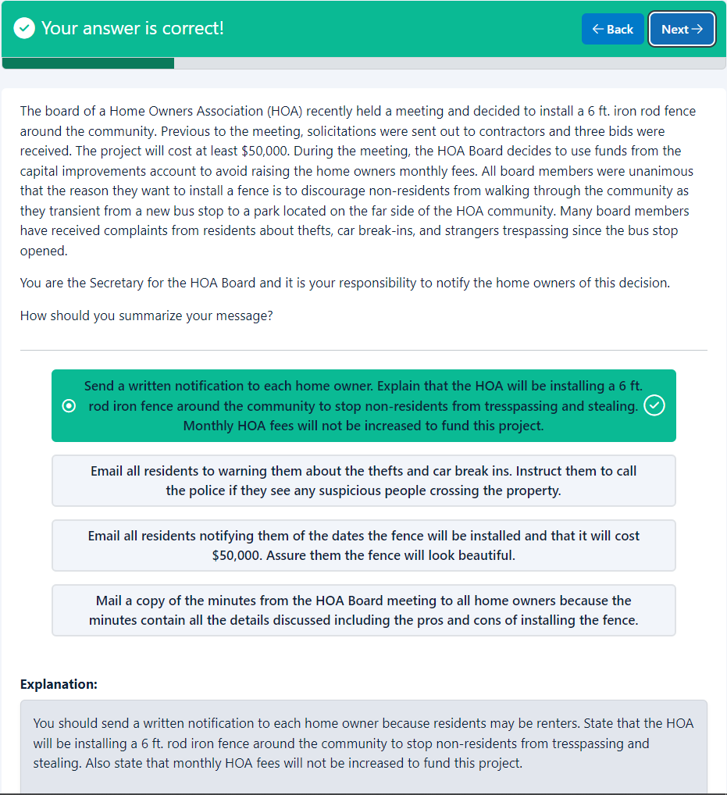

End of page
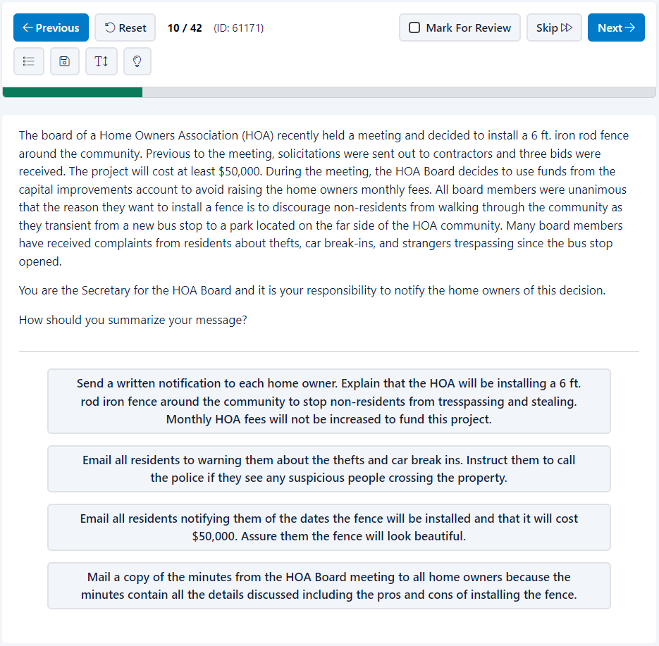
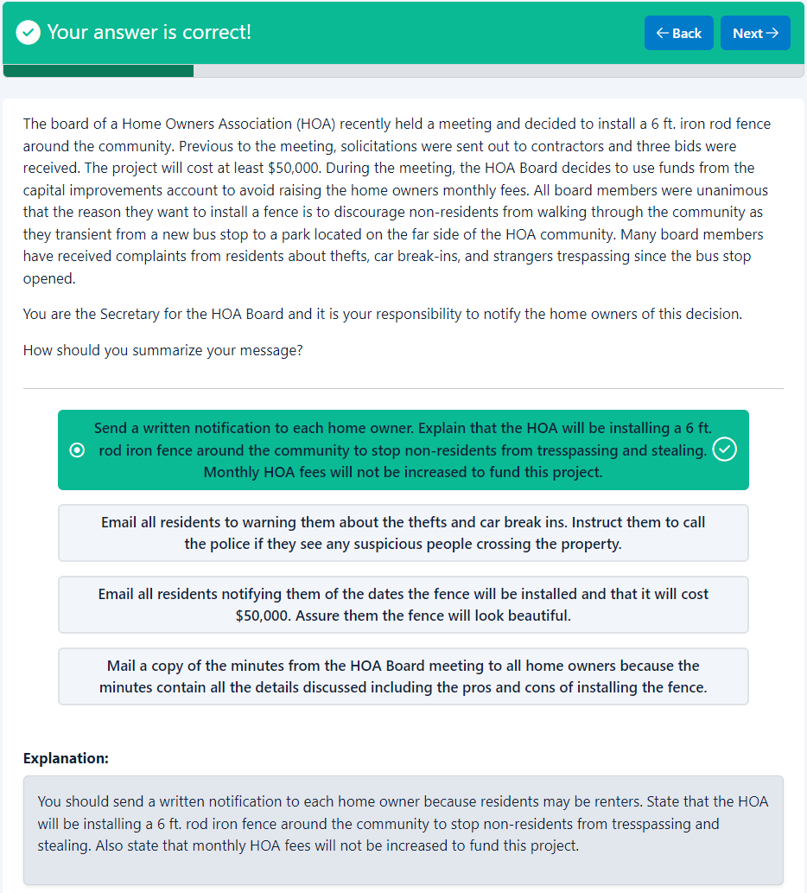
Top of Form
Your answer is correct!
BackNext
The board of a Home Owners Association (HOA) recently held a meeting and decided to install a 6 ft. iron rod fence around the community. Previous to the meeting, solicitations were sent out to contractors and three bids were received. The project will cost at least $50,000. During the meeting, the HOA Board decides to use funds from the capital improvements account to avoid raising the home owners monthly fees. All board members were unanimous that the reason they want to install a fence is to discourage non-residents from walking through the community as they transient from a new bus stop to a park located on the far side of the HOA community. Many board members have received complaints from residents about thefts, car break-ins, and strangers trespassing since the bus stop opened.
You are the Secretary for the HOA Board and it is your responsibility to notify the home owners of this decision.
How should you summarize your message?

- Send a written notification to each home owner. Explain that the HOA will be installing a 6 ft. rod iron fence around the community to stop non-residents from tresspassing and stealing. Monthly HOA fees will not be increased to fund this project.
- Email all residents to warning them about the thefts and car break ins. Instruct them to call the police if they see any suspicious people crossing the property.
- Email all residents notifying them of the dates the fence will be installed and that it will cost $50,000. Assure them the fence will look beautiful.
- Mail a copy of the minutes from the HOA Board meeting to all home owners because the minutes contain all the details discussed including the pros and cons of installing the fence.

Explanation
Explanation:
You should send a written notification to each home owner because residents may be renters. State that the HOA will be installing a 6 ft. rod iron fence around the community to stop non-residents from tresspassing and stealing. Also state that monthly HOA fees will not be increased to fund this project.
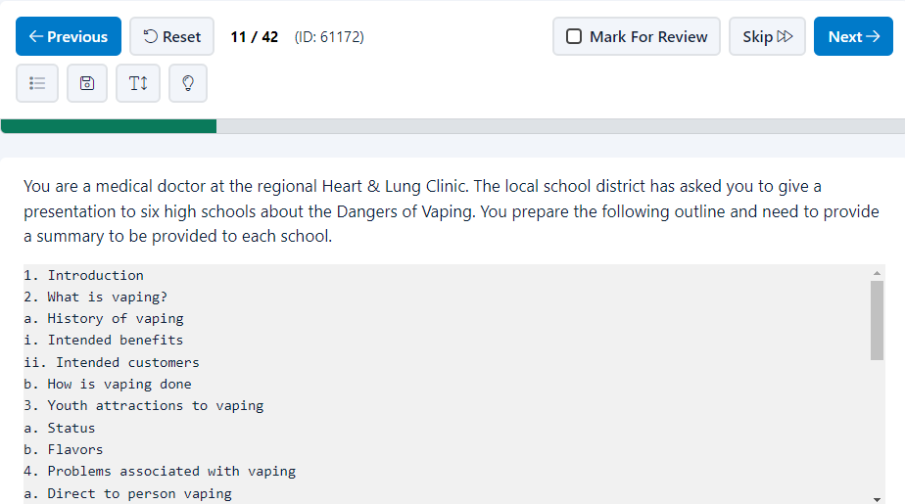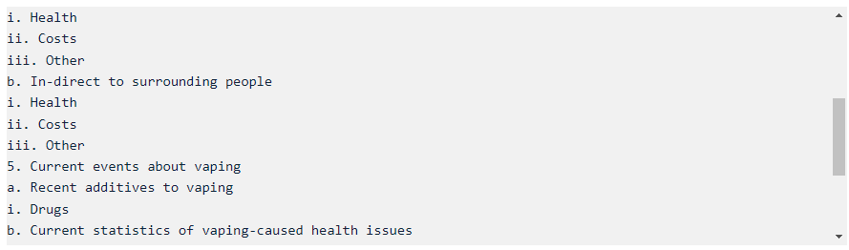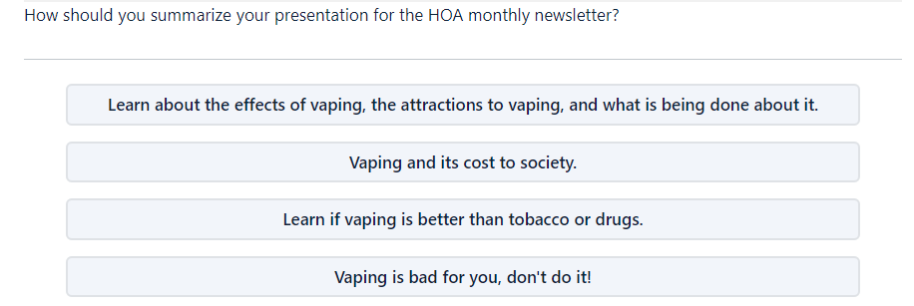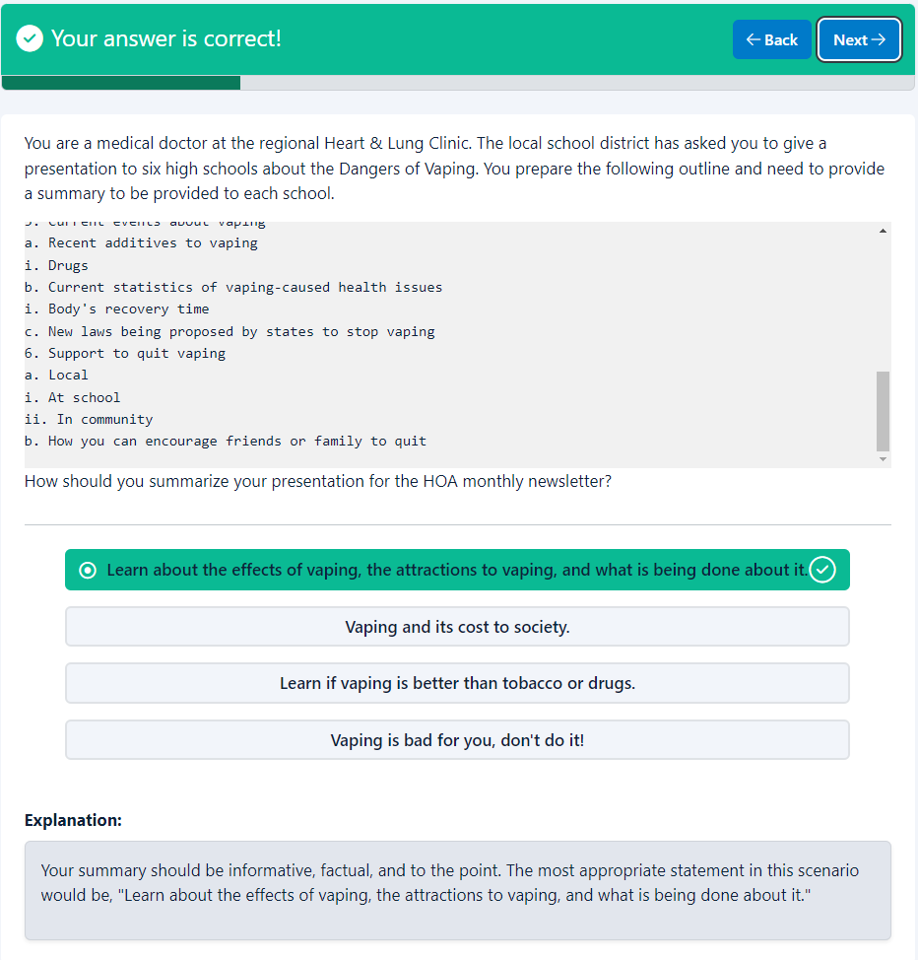

End of page
Top of Form
Question 11 of 42. Question ID: 6117211 / 42
(ID: 61172)

Mark For ReviewSkipNext
You are a medical doctor at the regional Heart & Lung Clinic. The local school district has asked you to give a presentation to six high schools about the Dangers of Vaping. You prepare the following outline and need to provide a summary to be provided to each school.
1. Introduction
2. What is vaping?
a. History of vaping
i. Intended benefits
ii. Intended customers
b. How is vaping done
3. Youth attractions to vaping
a. Status
b. Flavors
4. Problems associated with vaping
a. Direct to person vaping
i. Health
ii. Costs
iii. Other
b. In-direct to surrounding people
i. Health
ii. Costs
iii. Other
5. Current events about vaping
a. Recent additives to vaping
i. Drugs
b. Current statistics of vaping-caused health issues
i. Body's recovery time
c. New laws being proposed by states to stop vaping
6. Support to quit vaping
a. Local
i. At school
ii. In community
b. How you can encourage friends or family to quit
How should you summarize your presentation for the HOA monthly newsletter?

- Learn about the effects of vaping, the attractions to vaping, and what is being done about it.
- Vaping and its cost to society.
- Learn if vaping is better than tobacco or drugs.
- Vaping is bad for you, don't do it!

End of page
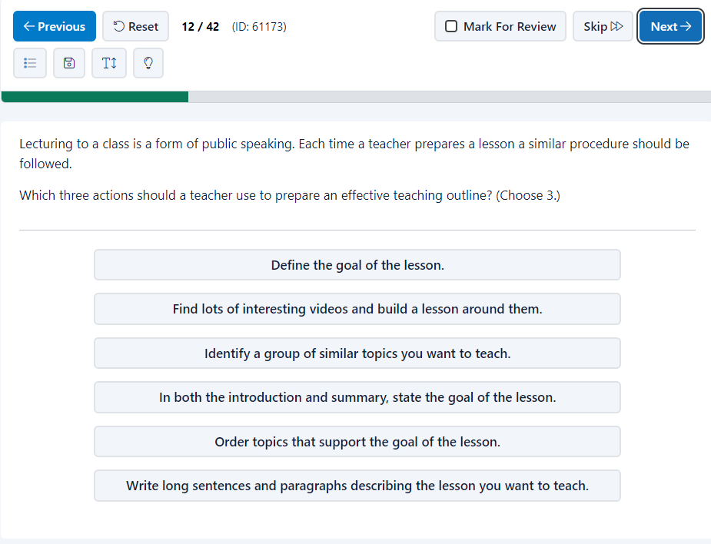
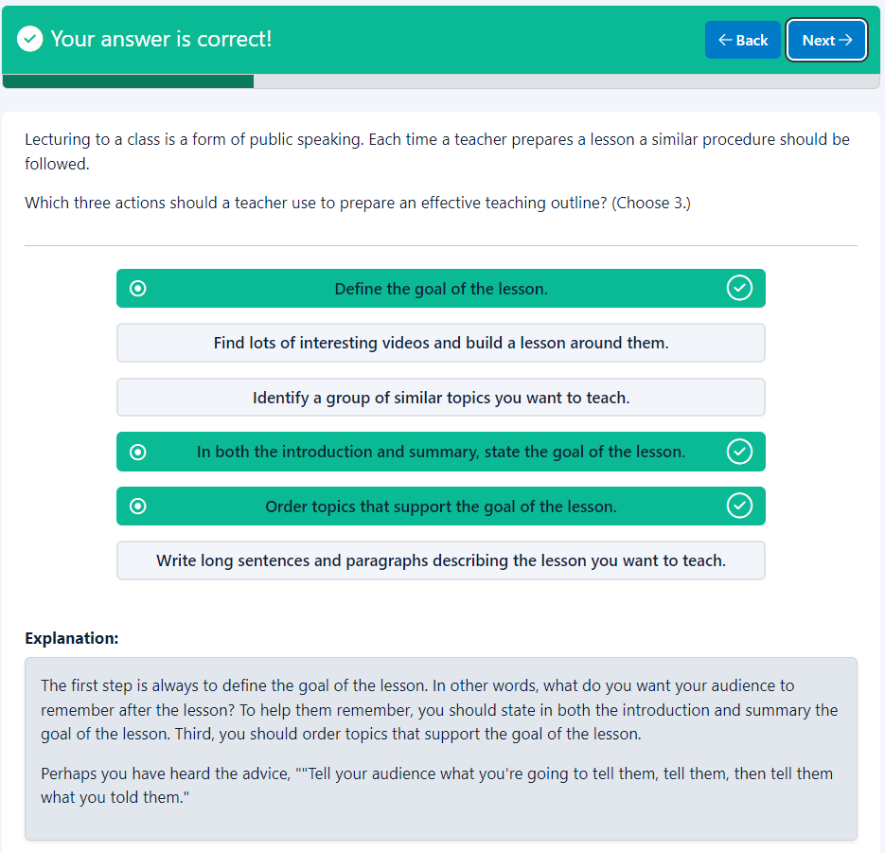
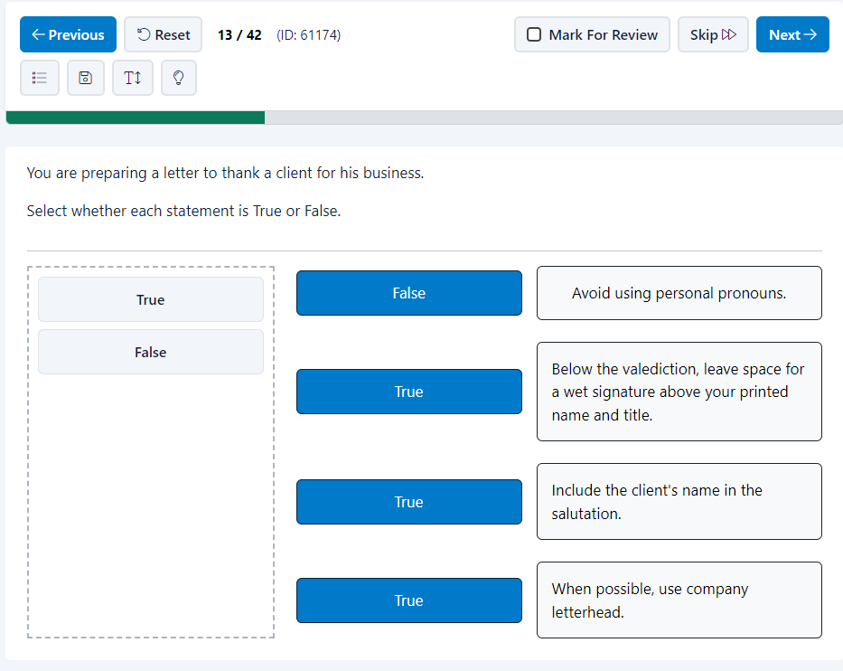
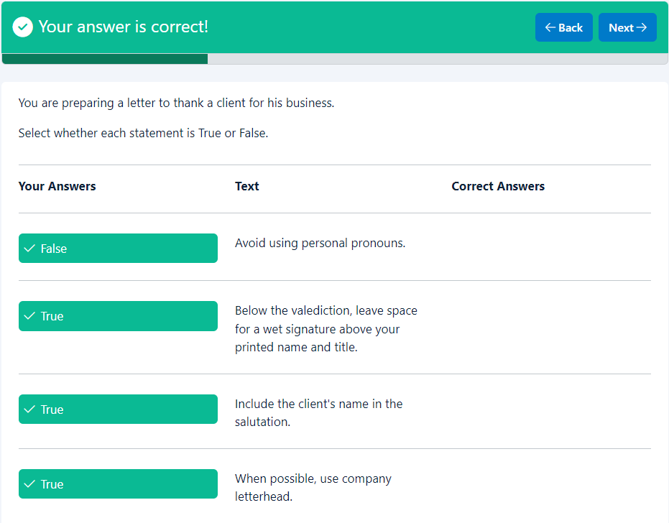
Your answer is correct!
BackNext
You are preparing a letter to thank a client for his business.
Select whether each statement is True or False.

Your Answers
Text
Correct Answers

False
Avoid using personal pronouns.

True
Below the valediction, leave space for a wet signature above your printed name and title.

True
Include the client's name in the salutation.

True
When possible, use company letterhead.

Explanation
Explanation:
Business letters should include the following:
* When possible, use company letterhead to give the letter a more professional appearance.
* Personalize the letter by using the client's name in the salutation.
* Close the letter leaving space below the valediction for a wet signature above your printed name and title
Hint: A salutation is a greeting used to open a letter. Examples of salutations are ""Dear John,"" or ""Hello Mr. Smith:"" or ""Greetings Ms. Brown"". A valediction is used to close a letter, such as ""Yours truly,"" or "" Sincerely,"" or ""Best regards"". A wet signature is a signature that is hand-written with an ink pen. Blue or black ink is typically used for business documents.

End of page
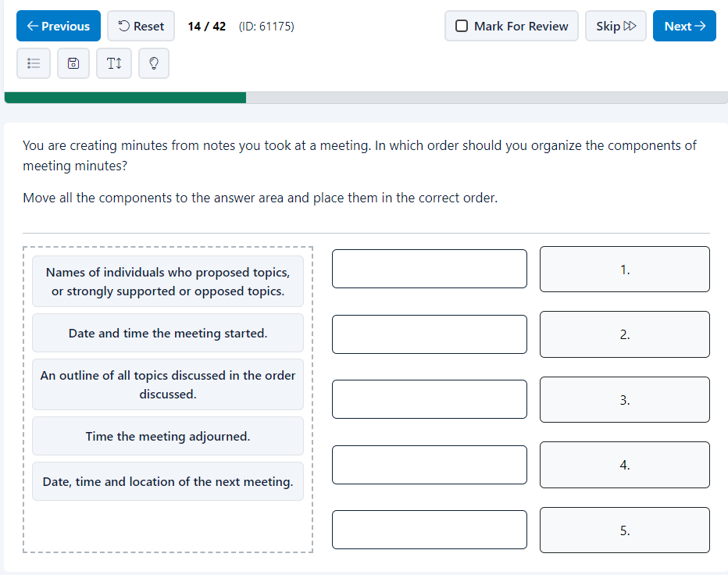
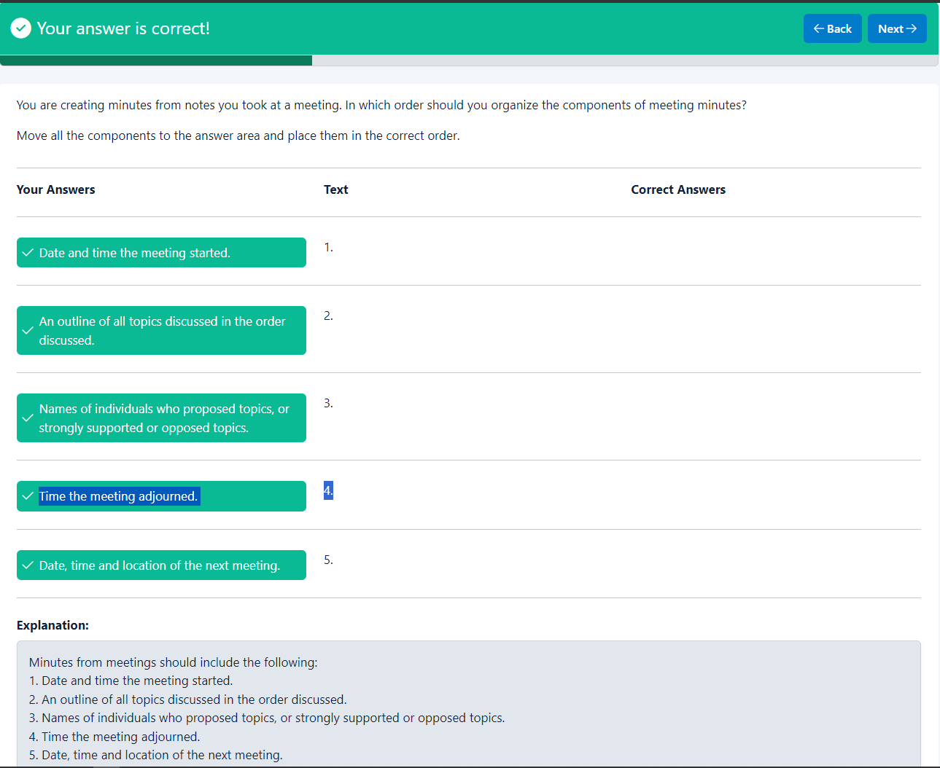
Your answer is correct!
BackNext
You are creating minutes from notes you took at a meeting. In which order should you organize the components of meeting minutes?
Move all the components to the answer area and place them in the correct order.

Your Answers
Text
Correct Answers

Date and time the meeting started.
1.

An outline of all topics discussed in the order discussed.
2.

Names of individuals who proposed topics, or strongly supported or opposed topics.
3.

Time the meeting adjourned.
4.

Date, time and location of the next meeting.
5.

Explanation
Explanation:
Minutes from meetings should include the following:
1. Date and time the meeting started.
2. An outline of all topics discussed in the order discussed.
3. Names of individuals who proposed topics, or strongly supported or opposed topics.
4. Time the meeting adjourned.
5. Date, time and location of the next meeting.

End of page
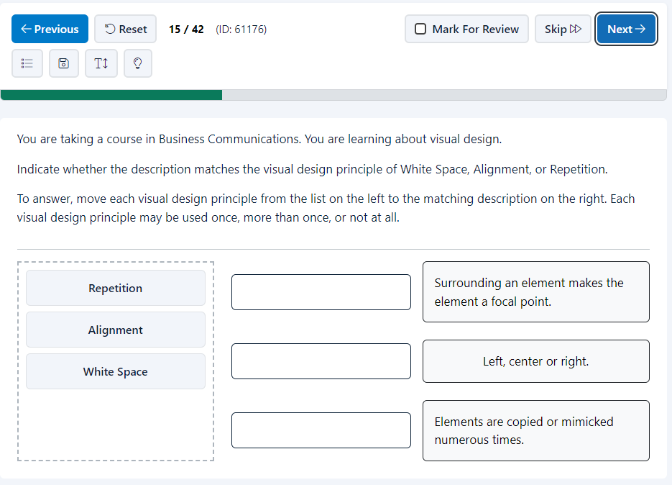
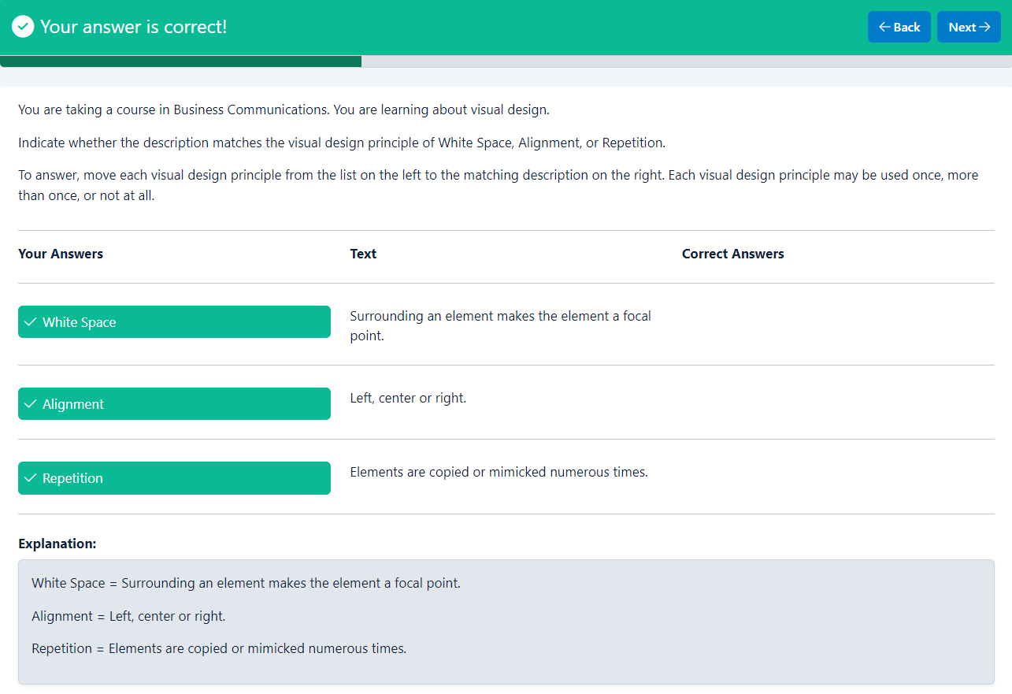
Your answer is correct!
BackNext
You are taking a course in Business Communications. You are learning about visual design.
Indicate whether the description matches the visual design principle of White Space, Alignment, or Repetition.
To answer, move each visual design principle from the list on the left to the matching description on the right. Each visual design principle may be used once, more than once, or not at all.

Your Answers
Text
Correct Answers

White Space
Surrounding an element makes the element a focal point.

Alignment
Left, center or right.

Repetition
Elements are copied or mimicked numerous times.

Explanation
Explanation:
White Space = Surrounding an element makes the element a focal point.
Alignment = Left, center or right.
Repetition = Elements are copied or mimicked numerous times.

End of page
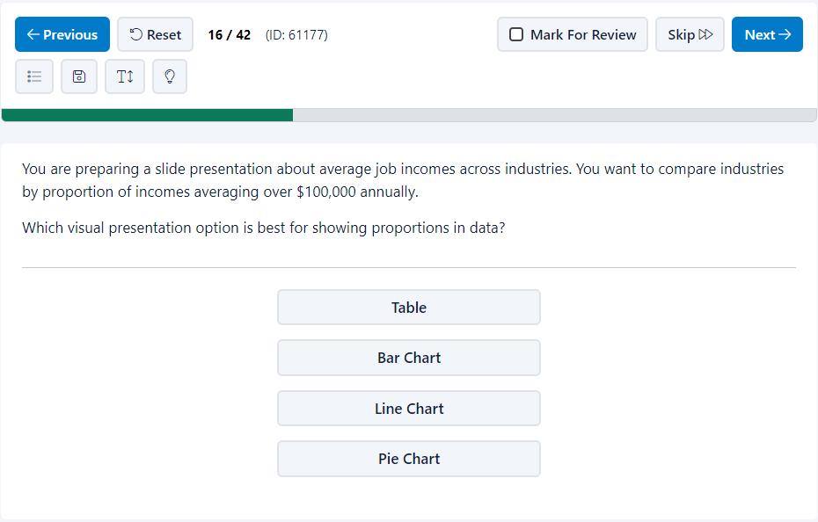
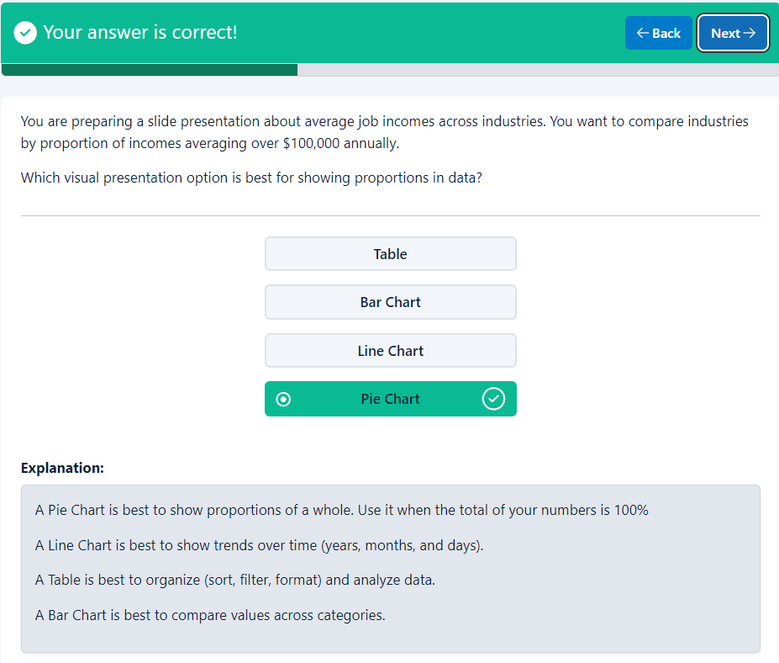
Your answer is correct!
BackNext
You are preparing a slide presentation about average job incomes across industries. You want to compare industries by proportion of incomes averaging over $100,000 annually.
Which visual presentation option is best for showing proportions in data?

- Table
- Bar Chart
- Line Chart
- Pie Chart
Explanation
Explanation:
A Pie Chart is best to show proportions of a whole. Use it when the total of your numbers is 100%
A Line Chart is best to show trends over time (years, months, and days).
A Table is best to organize (sort, filter, format) and analyze data.
A Bar Chart is best to compare values across categories.

End of page
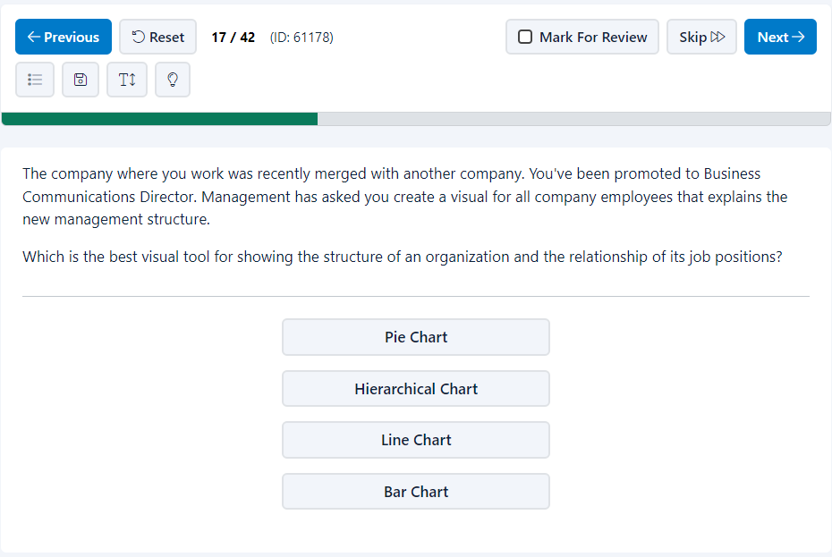
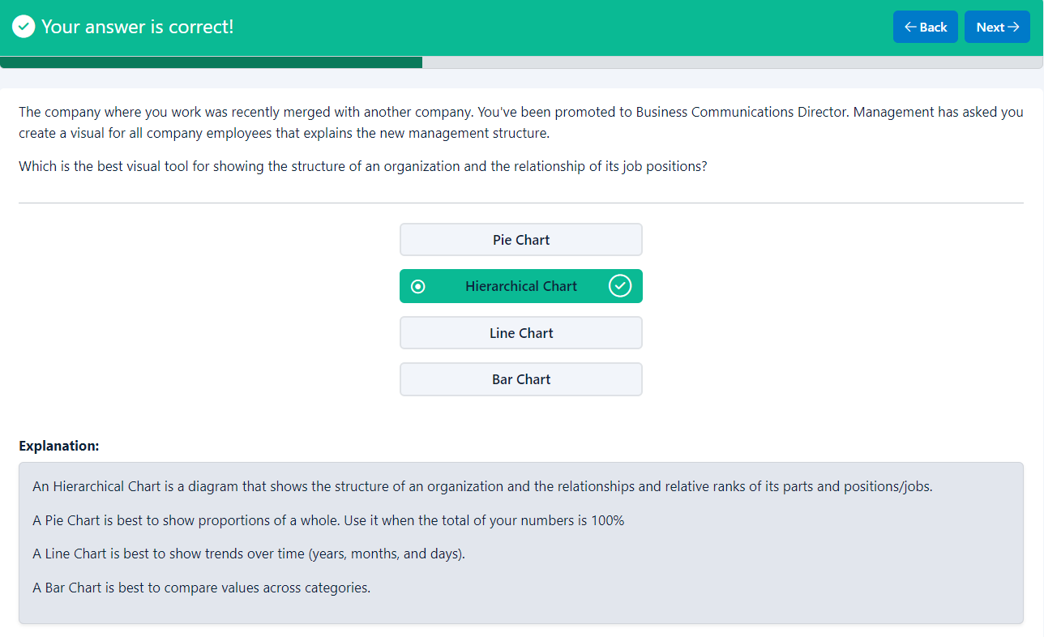
Your answer is correct!
BackNext
The company where you work was recently merged with another company. You've been promoted to Business Communications Director. Management has asked you create a visual for all company employees that explains the new management structure.
Which is the best visual tool for showing the structure of an organization and the relationship of its job positions?

- Pie Chart
- Hierarchical Chart
- Line Chart
- Bar Chart
Explanation
Explanation:
An Hierarchical Chart is a diagram that shows the structure of an organization and the relationships and relative ranks of its parts and positions/jobs.
A Pie Chart is best to show proportions of a whole. Use it when the total of your numbers is 100%
A Line Chart is best to show trends over time (years, months, and days).
A Bar Chart is best to compare values across categories.

End of page
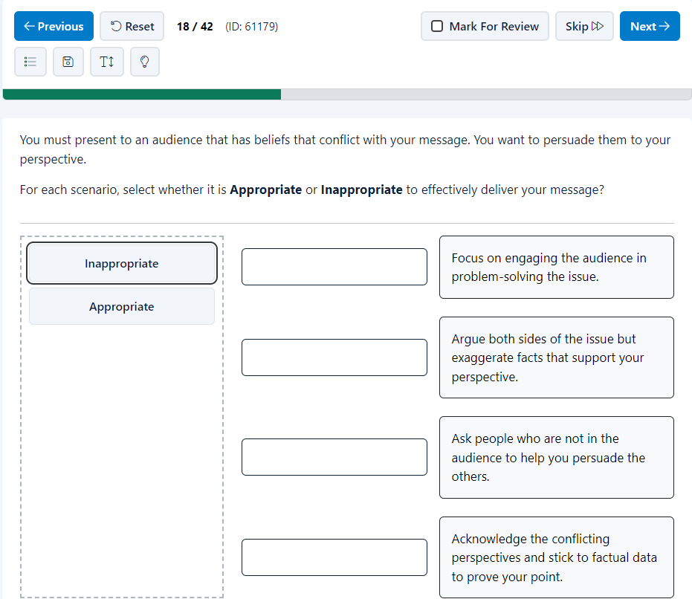
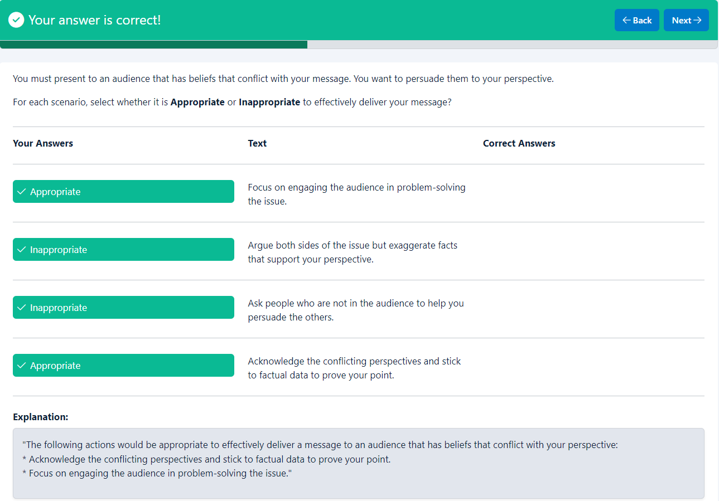
Your answer is correct!
BackNext
You must present to an audience that has beliefs that conflict with your message. You want to persuade them to your perspective.
For each scenario, select whether it is Appropriate or Inappropriate to effectively deliver your message?

Your Answers
Text
Correct Answers

Appropriate
Focus on engaging the audience in problem-solving the issue.

Inappropriate
Argue both sides of the issue but exaggerate facts that support your perspective.

Inappropriate
Ask people who are not in the audience to help you persuade the others.

Appropriate
Acknowledge the conflicting perspectives and stick to factual data to prove your point.

Explanation
Explanation:
"The following actions would be appropriate to effectively deliver a message to an audience that has beliefs that conflict with your perspective:
* Acknowledge the conflicting perspectives and stick to factual data to prove your point.
* Focus on engaging the audience in problem-solving the issue."

End of page
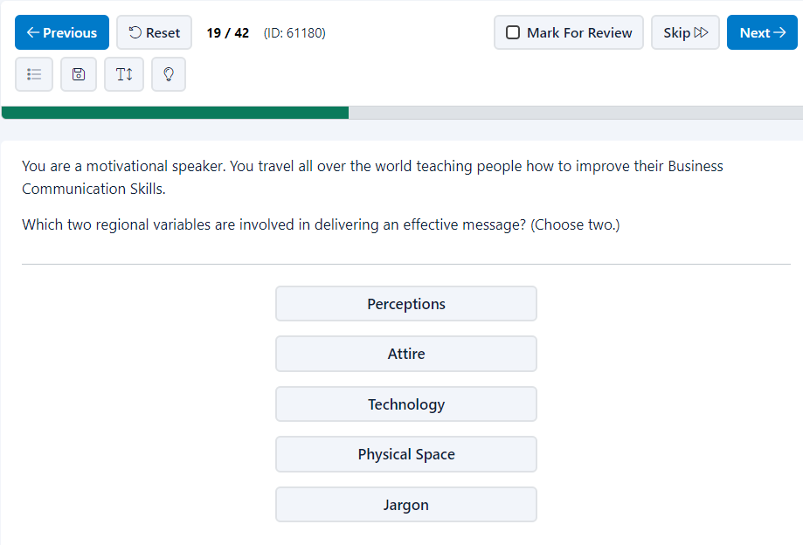
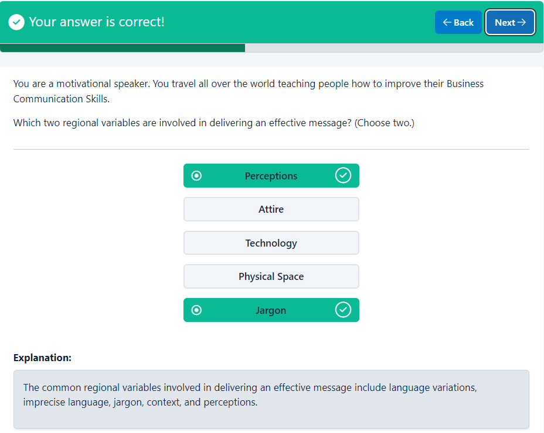
Your answer is correct!
BackNext
You are a motivational speaker. You travel all over the world teaching people how to improve their Business Communication Skills.
Which two regional variables are involved in delivering an effective message? (Choose two.)

- Perceptions
- Attire
- Technology
- Physical Space
- Jargon
Explanation
Explanation:
The common regional variables involved in delivering an effective message include language variations, imprecise language, jargon, context, and perceptions.

End of page
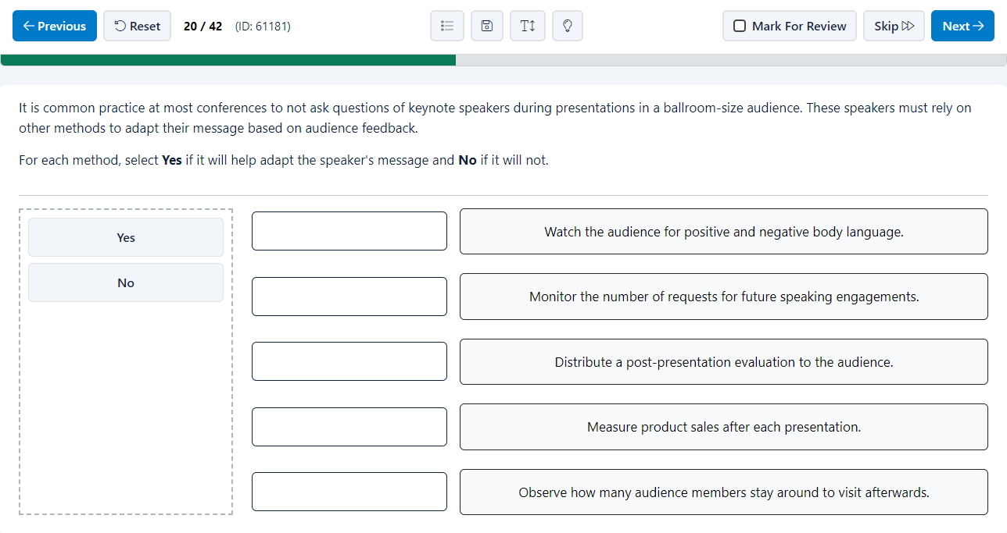
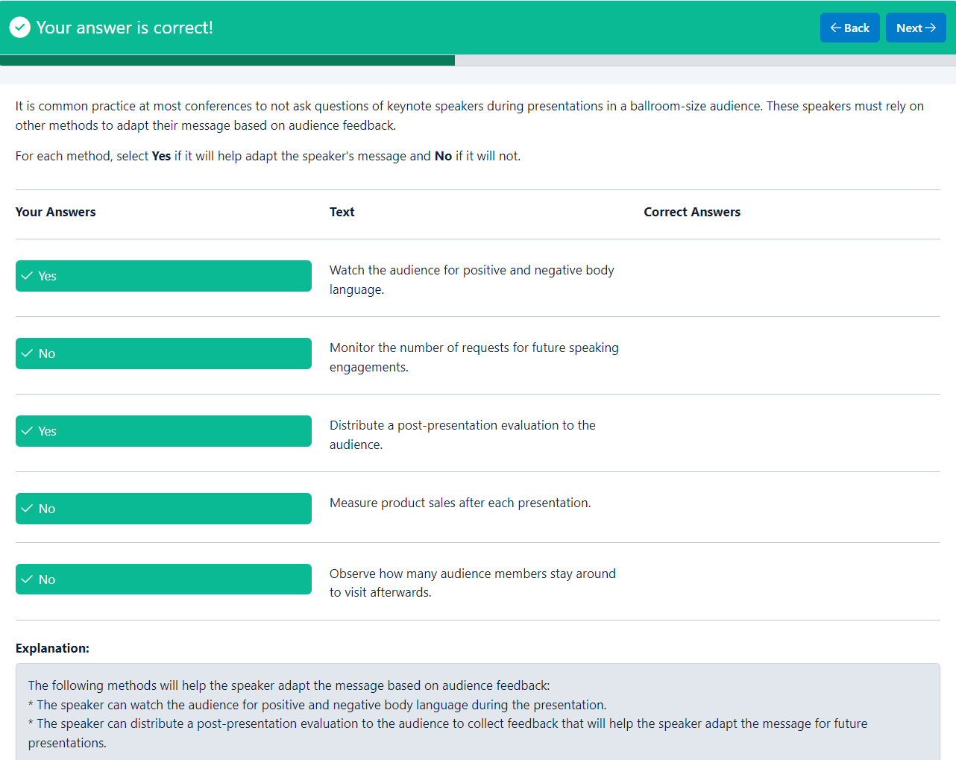
Your answer is correct!
BackNext
It is common practice at most conferences to not ask questions of keynote speakers during presentations in a ballroom-size audience. These speakers must rely on other methods to adapt their message based on audience feedback.
For each method, select Yes if it will help adapt the speaker's message and No if it will not.

Your Answers
Text
Correct Answers

Yes
Watch the audience for positive and negative body language.

No
Monitor the number of requests for future speaking engagements.

Yes
Distribute a post-presentation evaluation to the audience.

No
Measure product sales after each presentation.

No
Observe how many audience members stay around to visit afterwards.

Explanation
Explanation:
The following methods will help the speaker adapt the message based on audience feedback:
* The speaker can watch the audience for positive and negative body language during the presentation.
* The speaker can distribute a post-presentation evaluation to the audience to collect feedback that will help the speaker adapt the message for future presentations.

End of page
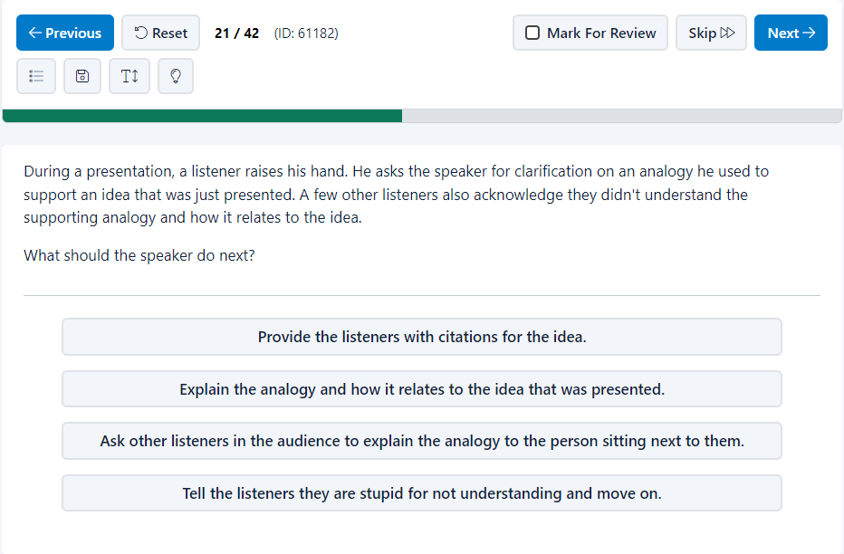
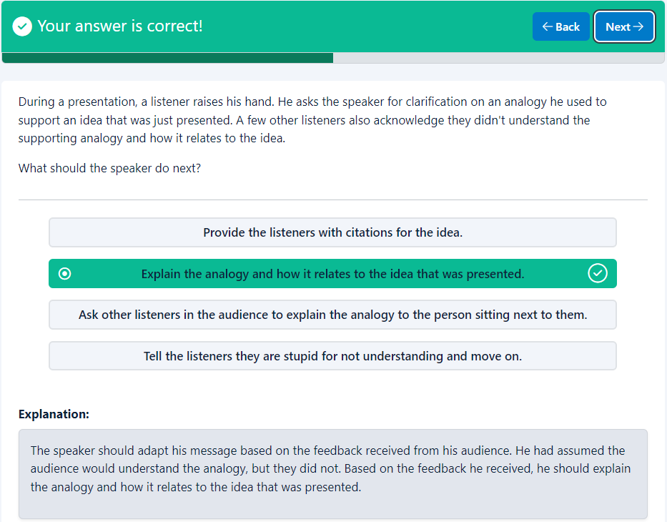
Your answer is correct!
BackNext
During a presentation, a listener raises his hand. He asks the speaker for clarification on an analogy he used to support an idea that was just presented. A few other listeners also acknowledge they didn't understand the supporting analogy and how it relates to the idea.
What should the speaker do next?

- Provide the listeners with citations for the idea.
- Explain the analogy and how it relates to the idea that was presented.
- Ask other listeners in the audience to explain the analogy to the person sitting next to them.
- Tell the listeners they are stupid for not understanding and move on.
Explanation
Explanation:
The speaker should adapt his message based on the feedback received from his audience. He had assumed the audience would understand the analogy, but they did not. Based on the feedback he received, he should explain the analogy and how it relates to the idea that was presented.

End of page
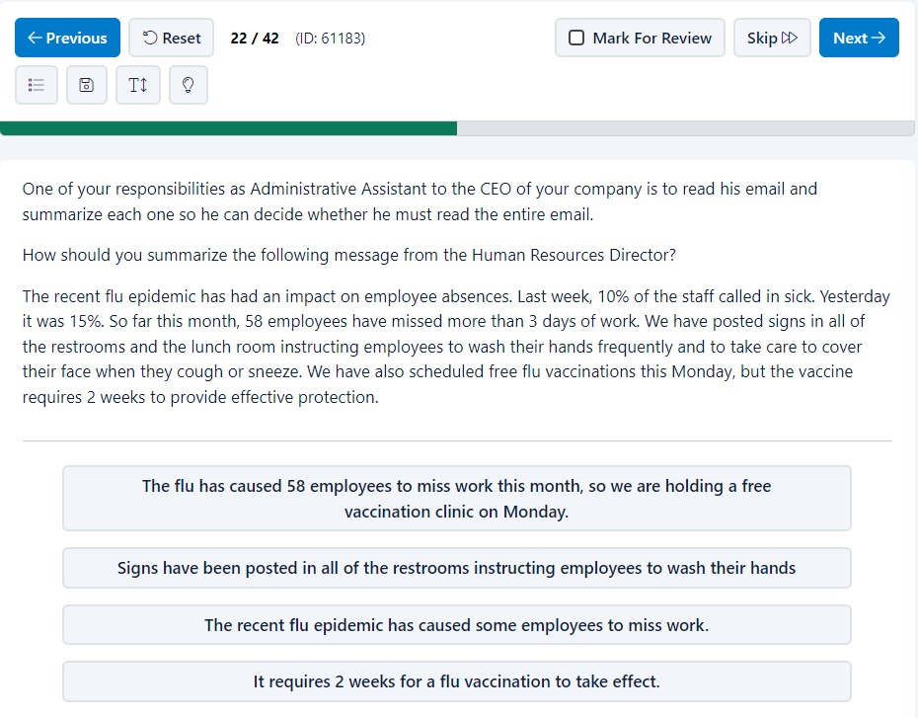
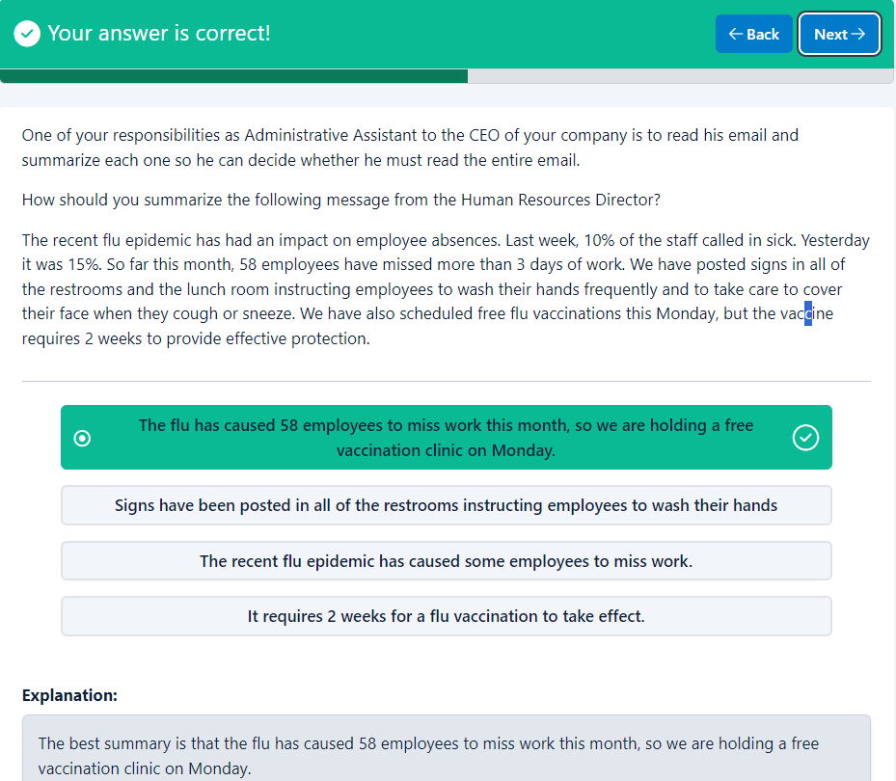
Your answer is correct!
BackNext
One of your responsibilities as Administrative Assistant to the CEO of your company is to read his email and summarize each one so he can decide whether he must read the entire email.
How should you summarize the following message from the Human Resources Director?
The recent flu epidemic has had an impact on employee absences. Last week, 10% of the staff called in sick. Yesterday it was 15%. So far this month, 58 employees have missed more than 3 days of work. We have posted signs in all of the restrooms and the lunch room instructing employees to wash their hands frequently and to take care to cover their face when they cough or sneeze. We have also scheduled free flu vaccinations this Monday, but the vaccine requires 2 weeks to provide effective protection.

- The flu has caused 58 employees to miss work this month, so we are holding a free vaccination clinic on Monday.
- Signs have been posted in all of the restrooms instructing employees to wash their hands
- The recent flu epidemic has caused some employees to miss work.
- It requires 2 weeks for a flu vaccination to take effect.
Explanation
Explanation:
The best summary is that the flu has caused 58 employees to miss work this month, so we are holding a free vaccination clinic on Monday.

End of page
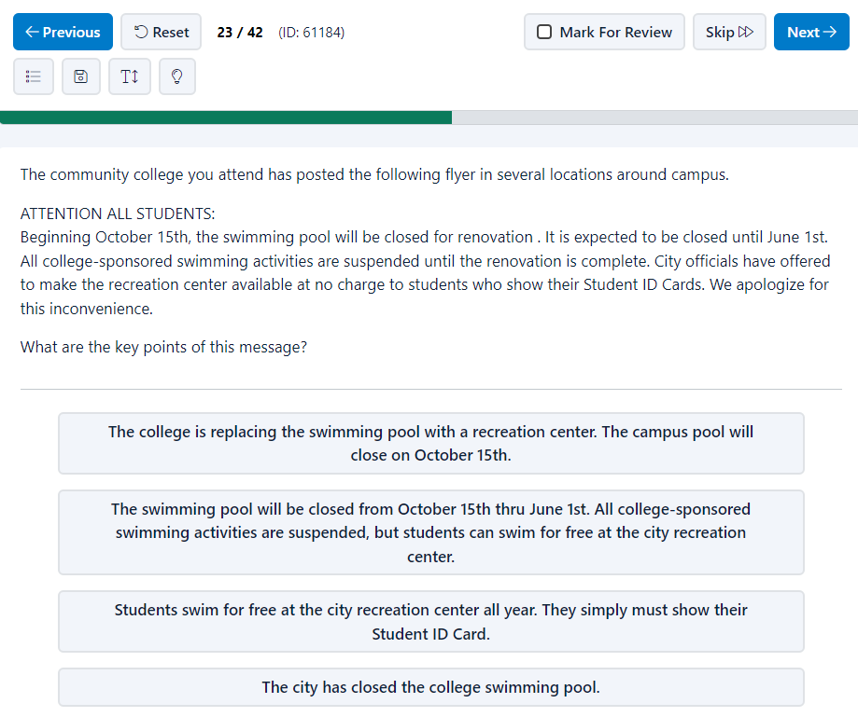
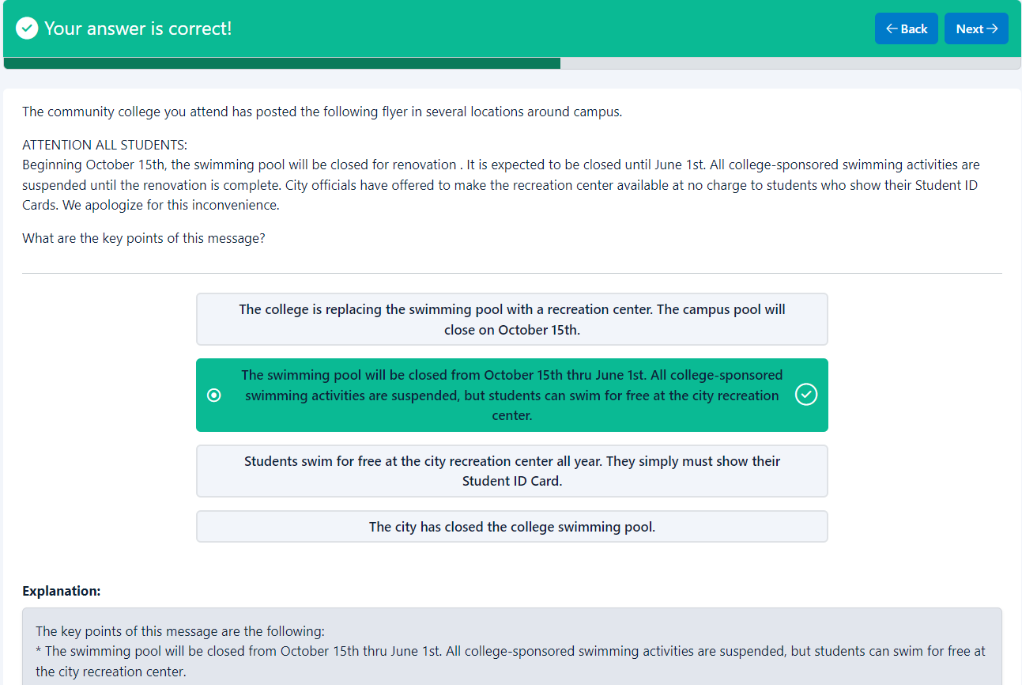
Your answer is correct!
BackNext
The community college you attend has posted the following flyer in several locations around campus.
ATTENTION ALL STUDENTS:
Beginning October 15th, the swimming pool will be closed for renovation . It is expected to be closed until June 1st. All college-sponsored swimming activities are suspended until the renovation is complete. City officials have offered to make the recreation center available at no charge to students who show their Student ID Cards. We apologize for this inconvenience.
What are the key points of this message?

- The college is replacing the swimming pool with a recreation center. The campus pool will close on October 15th.
- The swimming pool will be closed from October 15th thru June 1st. All college-sponsored swimming activities are suspended, but students can swim for free at the city recreation center.
- Students swim for free at the city recreation center all year. They simply must show their Student ID Card.
- The city has closed the college swimming pool.
Explanation
Explanation:
The key points of this message are the following:
* The swimming pool will be closed from October 15th thru June 1st. All college-sponsored swimming activities are suspended, but students can swim for free at the city recreation center.

End of page
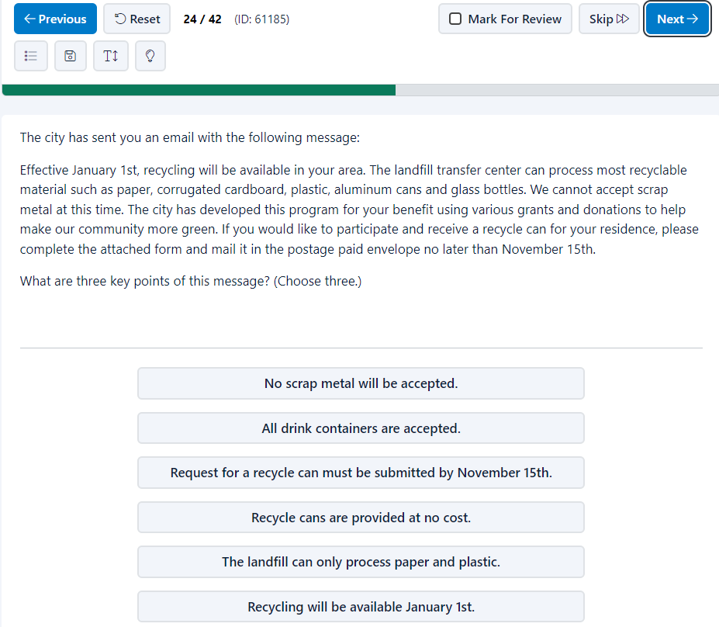
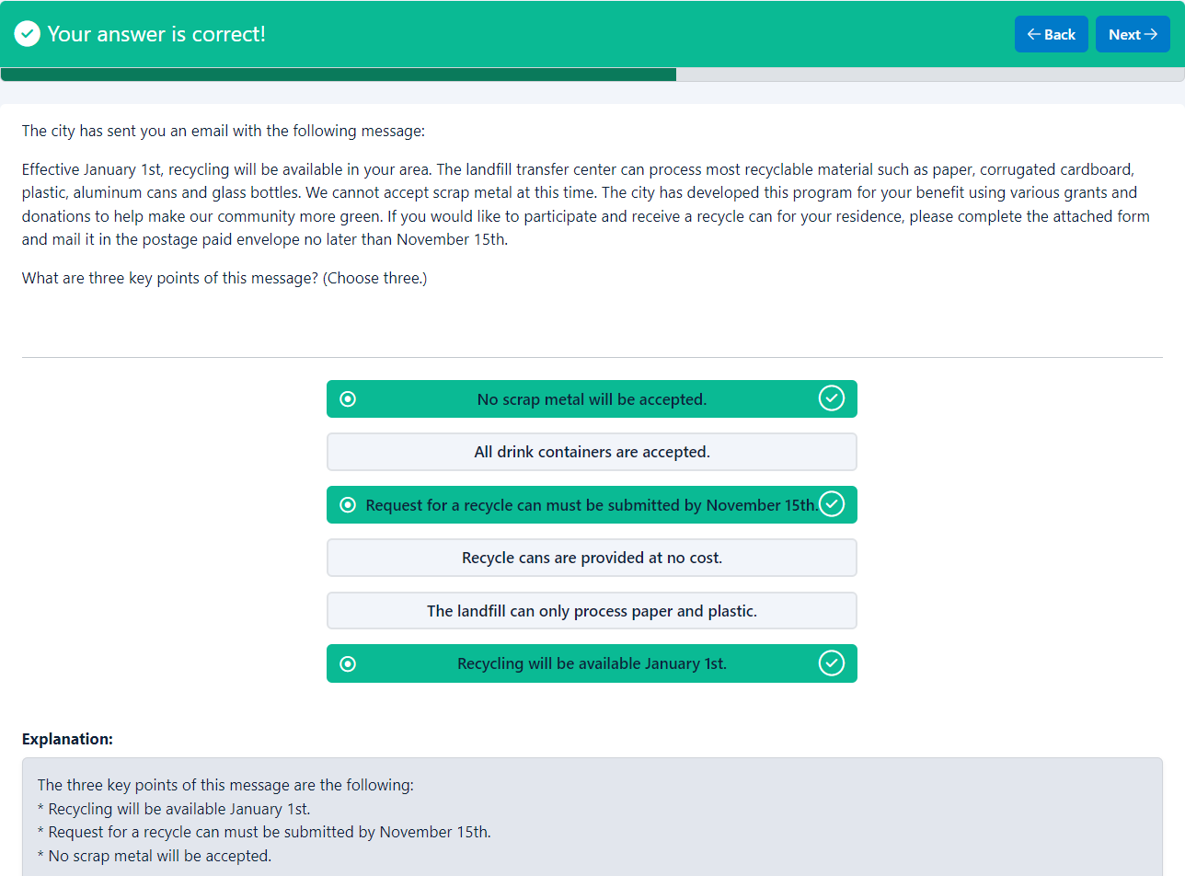
Your answer is correct!
BackNext
The city has sent you an email with the following message:
Effective January 1st, recycling will be available in your area. The landfill transfer center can process most recyclable material such as paper, corrugated cardboard, plastic, aluminum cans and glass bottles. We cannot accept scrap metal at this time. The city has developed this program for your benefit using various grants and donations to help make our community more green. If you would like to participate and receive a recycle can for your residence, please complete the attached form and mail it in the postage paid envelope no later than November 15th.
What are three key points of this message? (Choose three.)

Explanation
Explanation:
The three key points of this message are the following:
* Recycling will be available January 1st.
* Request for a recycle can must be submitted by November 15th.
* No scrap metal will be accepted.

End of page
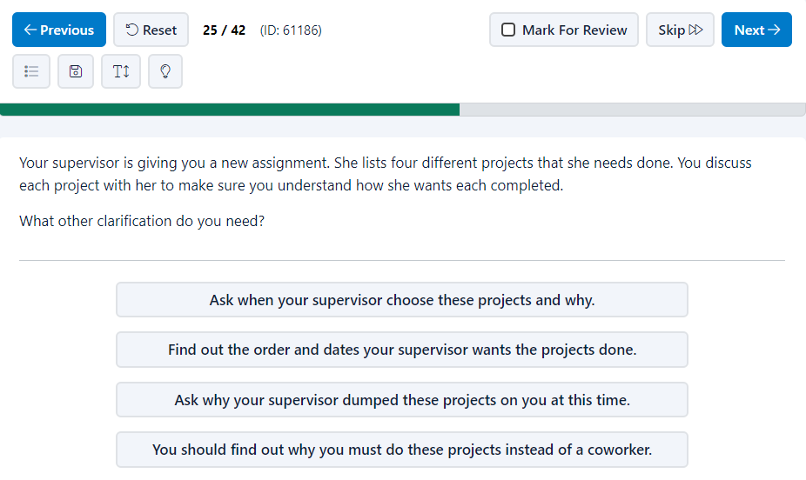

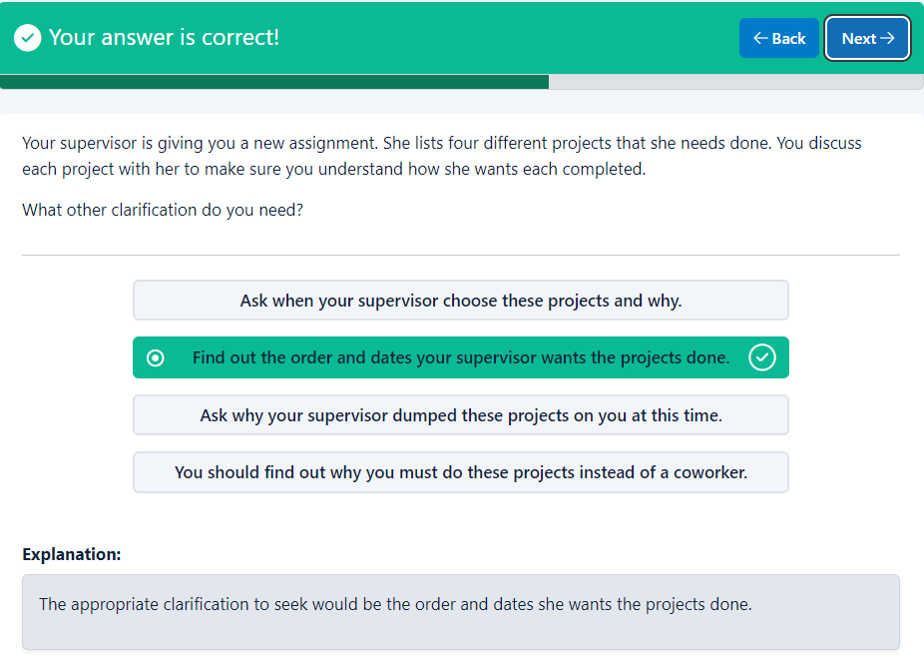
Your answer is correct!
BackNext
Your supervisor is giving you a new assignment. She lists four different projects that she needs done. You discuss each project with her to make sure you understand how she wants each completed.
What other clarification do you need?

- Ask when your supervisor choose these projects and why.
- Find out the order and dates your supervisor wants the projects done.
- Ask why your supervisor dumped these projects on you at this time.
- You should find out why you must do these projects instead of a coworker.
Explanation
Explanation:
The appropriate clarification to seek would be the order and dates she wants the projects done.

End of page
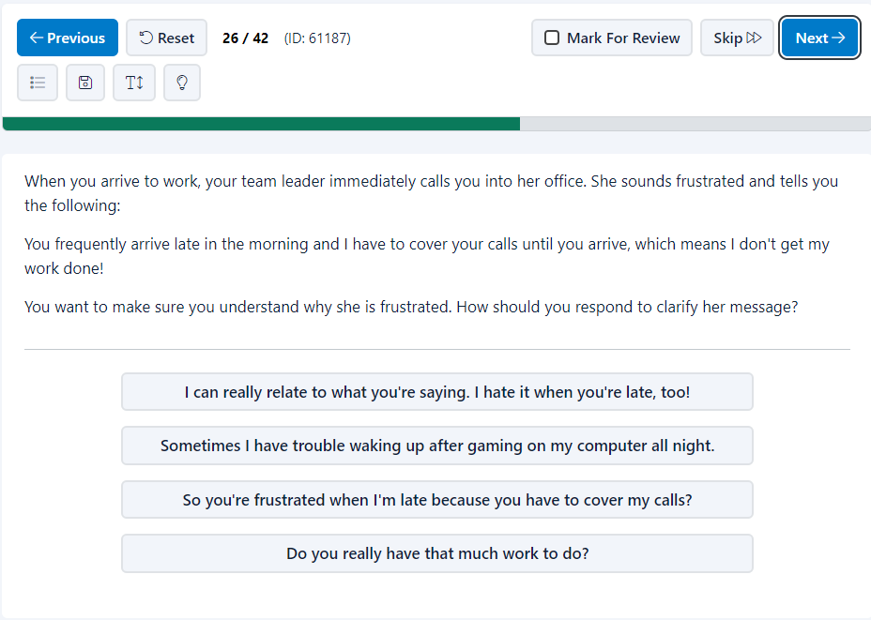
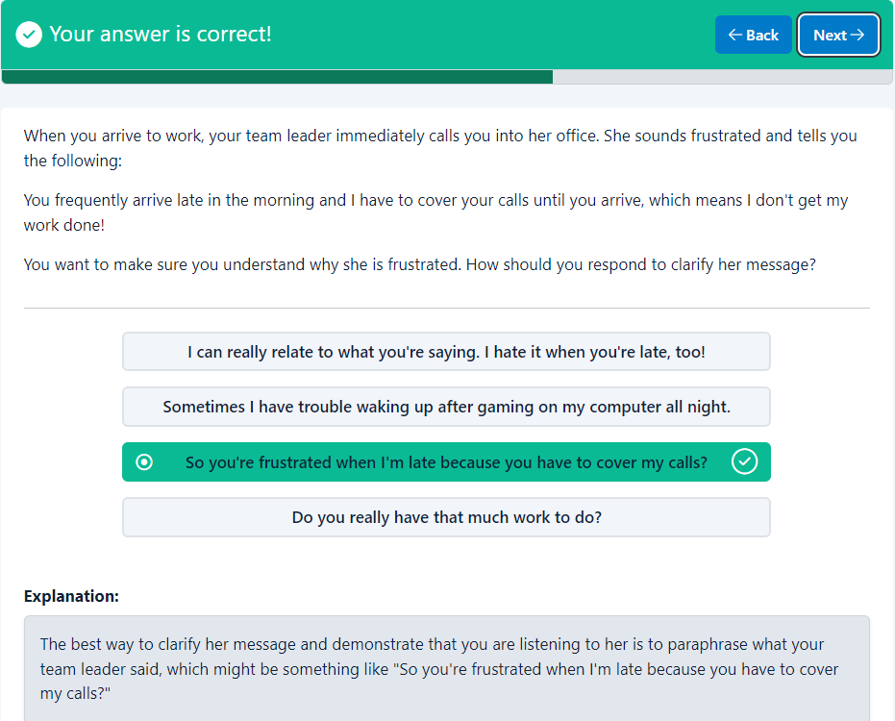
Your answer is correct!
BackNext
When you arrive to work, your team leader immediately calls you into her office. She sounds frustrated and tells you the following:
You frequently arrive late in the morning and I have to cover your calls until you arrive, which means I don't get my work done!
You want to make sure you understand why she is frustrated. How should you respond to clarify her message?

- I can really relate to what you're saying. I hate it when you're late, too!
- Sometimes I have trouble waking up after gaming on my computer all night.
- So you're frustrated when I'm late because you have to cover my calls?
- Do you really have that much work to do?
Explanation
Explanation:
The best way to clarify her message and demonstrate that you are listening to her is to paraphrase what your team leader said, which might be something like "So you're frustrated when I'm late because you have to cover my calls?"

End of page
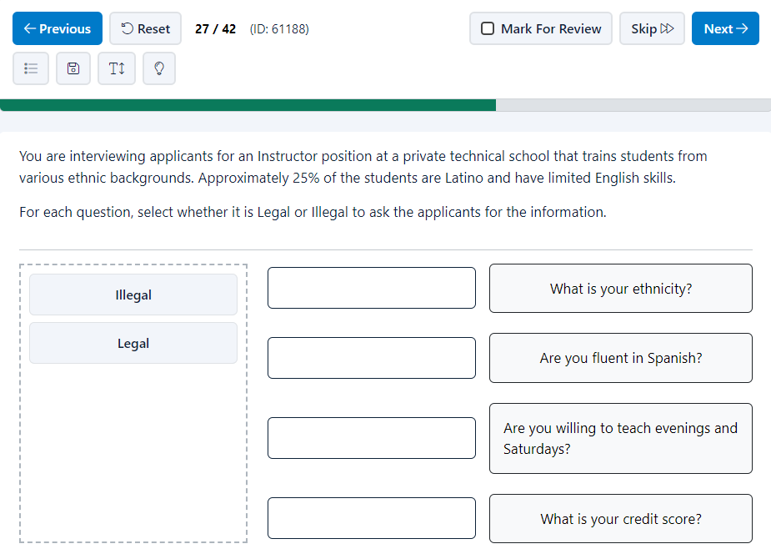
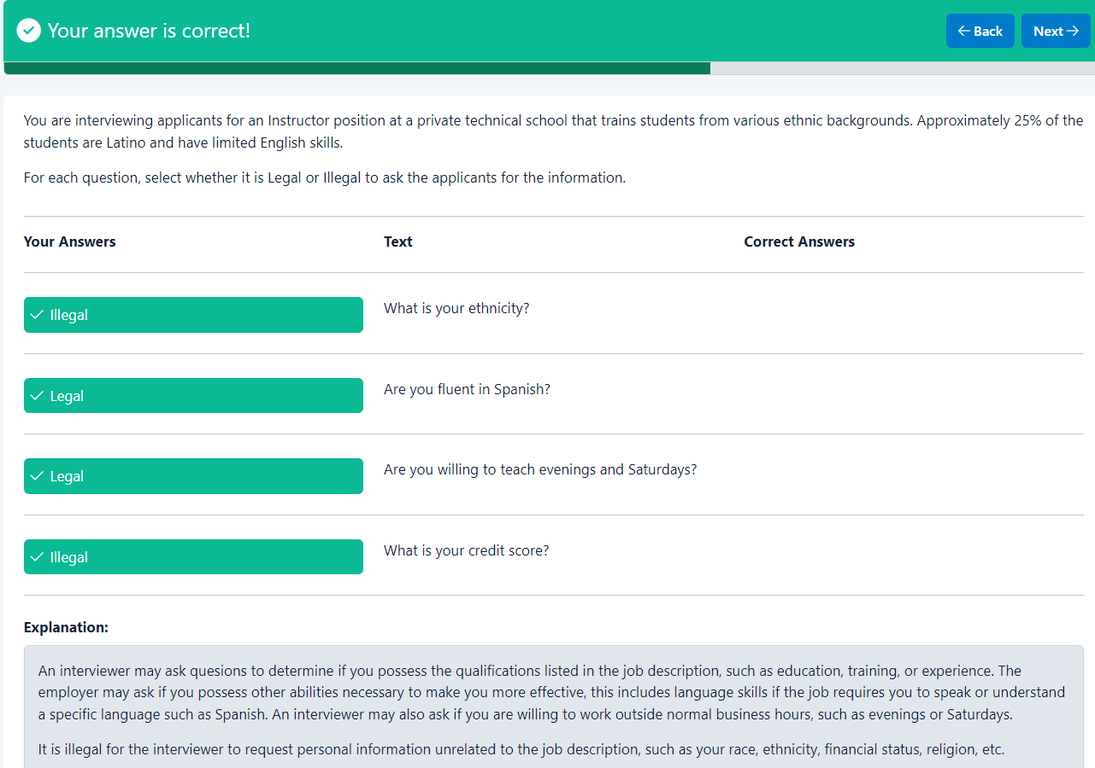
Your answer is correct!
BackNext
You are interviewing applicants for an Instructor position at a private technical school that trains students from various ethnic backgrounds. Approximately 25% of the students are Latino and have limited English skills.
For each question, select whether it is Legal or Illegal to ask the applicants for the information.

Your Answers
Text
Correct Answers

Illegal
What is your ethnicity?

Legal
Are you fluent in Spanish?

Legal
Are you willing to teach evenings and Saturdays?

Illegal
What is your credit score?

Explanation
Explanation:
An interviewer may ask quesions to determine if you possess the qualifications listed in the job description, such as education, training, or experience. The employer may ask if you possess other abilities necessary to make you more effective, this includes language skills if the job requires you to speak or understand a specific language such as Spanish. An interviewer may also ask if you are willing to work outside normal business hours, such as evenings or Saturdays.
It is illegal for the interviewer to request personal information unrelated to the job description, such as your race, ethnicity, financial status, religion, etc.

End of page
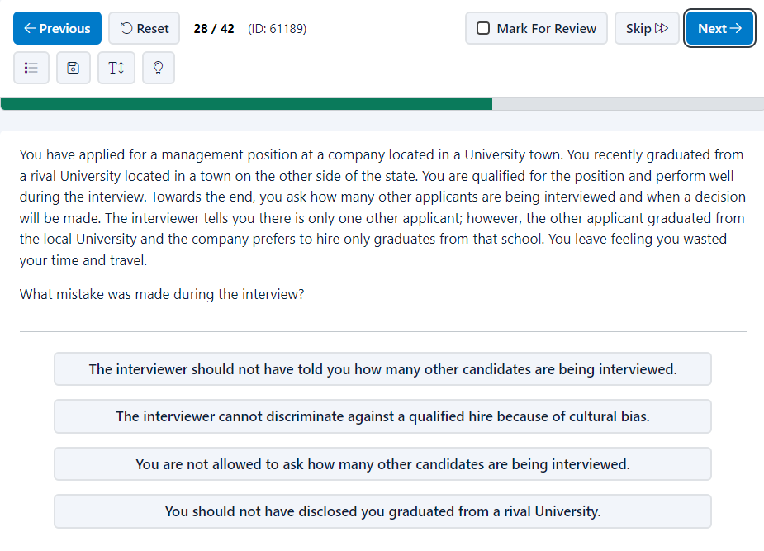
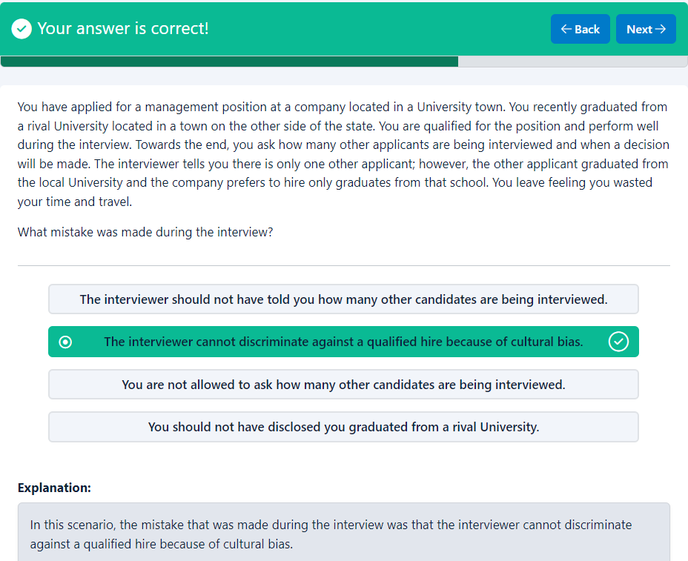
Your answer is correct!
BackNext
You have applied for a management position at a company located in a University town. You recently graduated from a rival University located in a town on the other side of the state. You are qualified for the position and perform well during the interview. Towards the end, you ask how many other applicants are being interviewed and when a decision will be made. The interviewer tells you there is only one other applicant; however, the other applicant graduated from the local University and the company prefers to hire only graduates from that school. You leave feeling you wasted your time and travel.
What mistake was made during the interview?

- The interviewer should not have told you how many other candidates are being interviewed.
- The interviewer cannot discriminate against a qualified hire because of cultural bias.
- You are not allowed to ask how many other candidates are being interviewed.
- You should not have disclosed you graduated from a rival University.
Explanation
Explanation:
In this scenario, the mistake that was made during the interview was that the interviewer cannot discriminate against a qualified hire because of cultural bias.

End of page
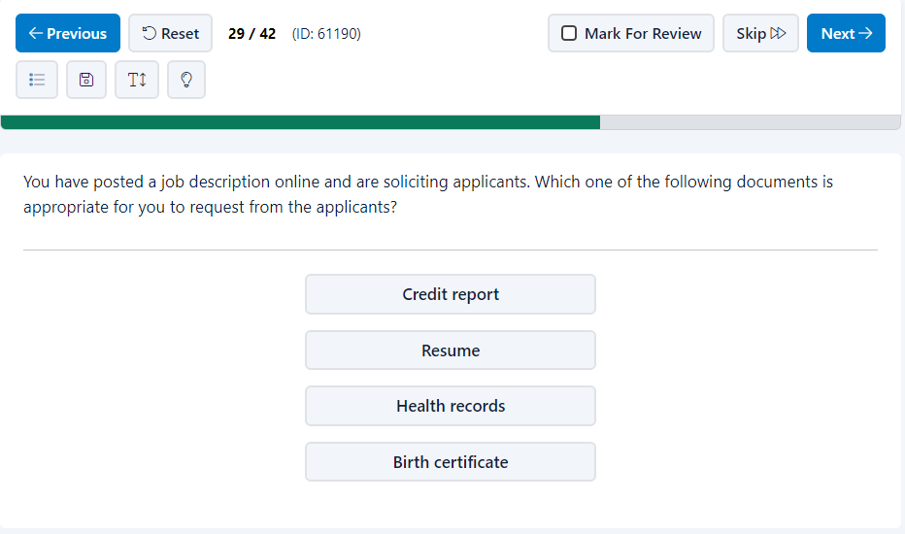
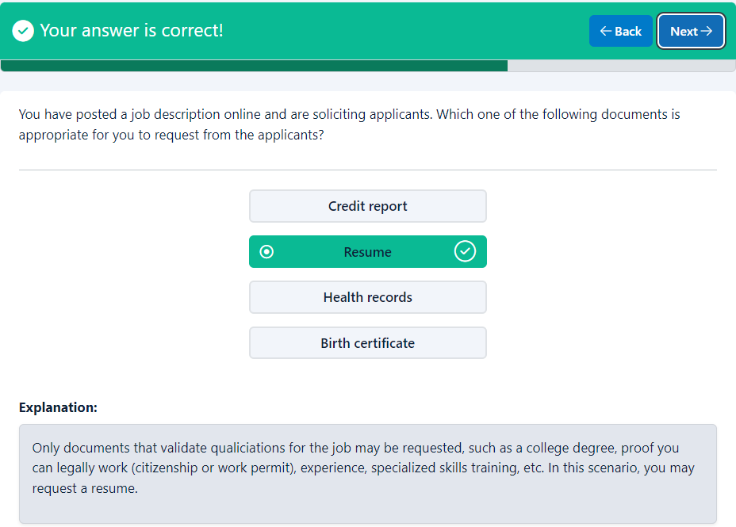
Your answer is correct!
BackNext
You have posted a job description online and are soliciting applicants. Which one of the following documents is appropriate for you to request from the applicants?

- Credit report
- Resume
- Health records
- Birth certificate
Explanation
Explanation:
Only documents that validate qualiciations for the job may be requested, such as a college degree, proof you can legally work (citizenship or work permit), experience, specialized skills training, etc. In this scenario, you may request a resume.

End of page
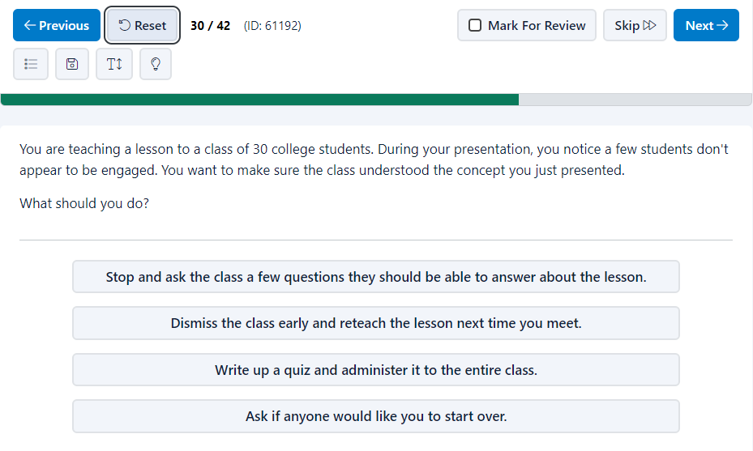
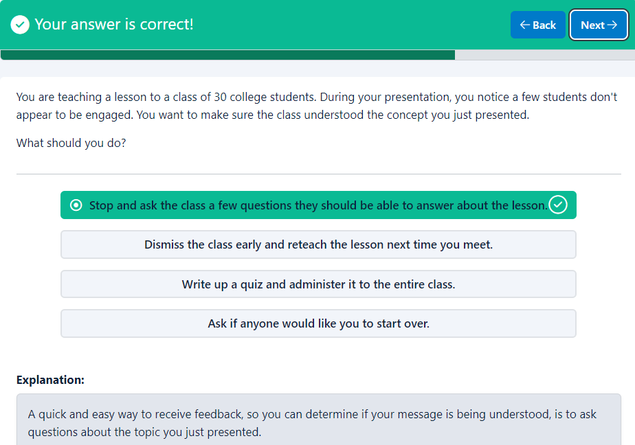
Your answer is correct!
BackNext
You are teaching a lesson to a class of 30 college students. During your presentation, you notice a few students don't appear to be engaged. You want to make sure the class understood the concept you just presented.
What should you do?

- Stop and ask the class a few questions they should be able to answer about the lesson.
- Dismiss the class early and reteach the lesson next time you meet.
- Write up a quiz and administer it to the entire class.
- Ask if anyone would like you to start over.
Explanation
Explanation:
A quick and easy way to receive feedback, so you can determine if your message is being understood, is to ask questions about the topic you just presented.

End of page
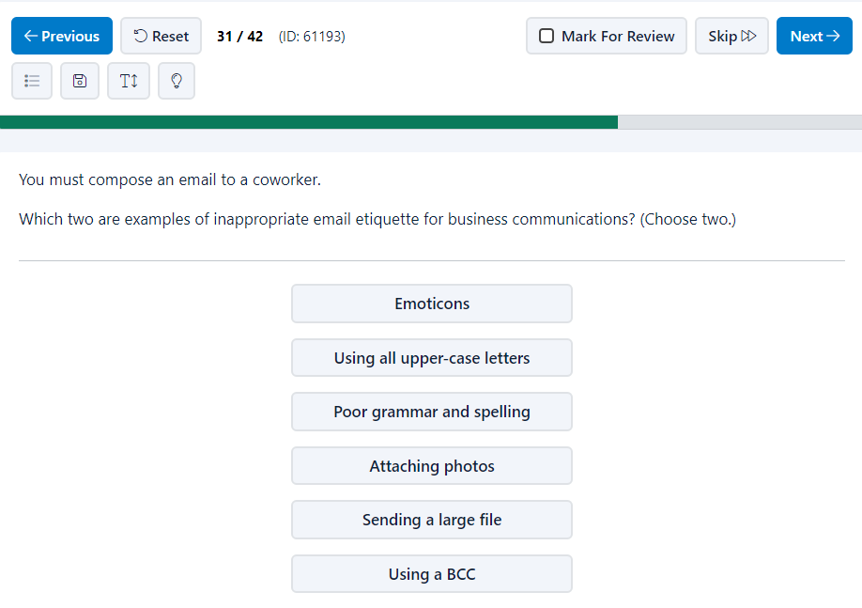
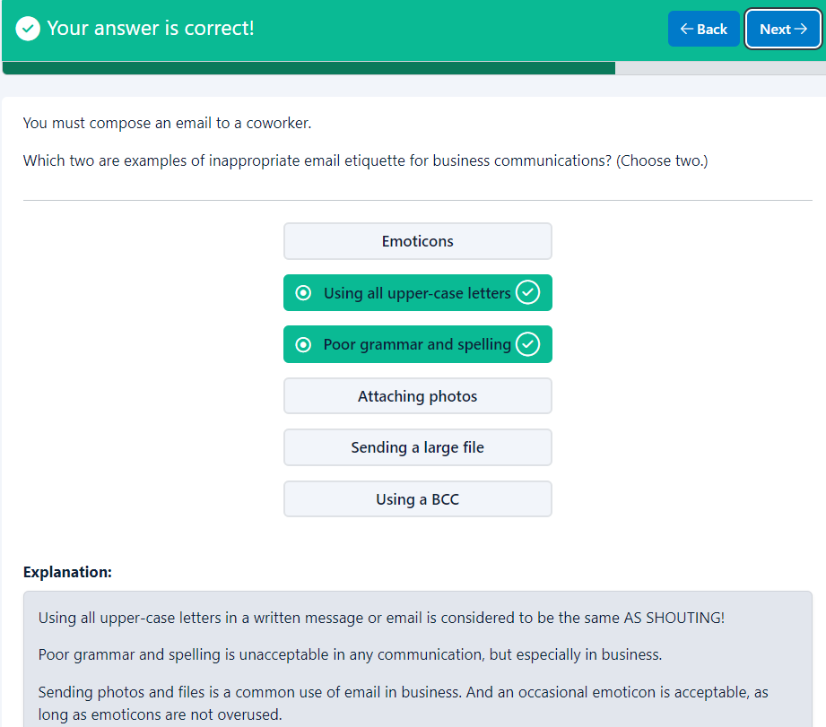
Your answer is correct!
BackNext
You must compose an email to a coworker.
Which two are examples of inappropriate email etiquette for business communications? (Choose two.)

- Emoticons
- Using all upper-case letters
- Poor grammar and spelling
- Attaching photos
- Sending a large file
- Using a BCC
Explanation
Explanation:
Using all upper-case letters in a written message or email is considered to be the same AS SHOUTING!
Poor grammar and spelling is unacceptable in any communication, but especially in business.
Sending photos and files is a common use of email in business. And an occasional emoticon is acceptable, as long as emoticons are not overused.

End of page
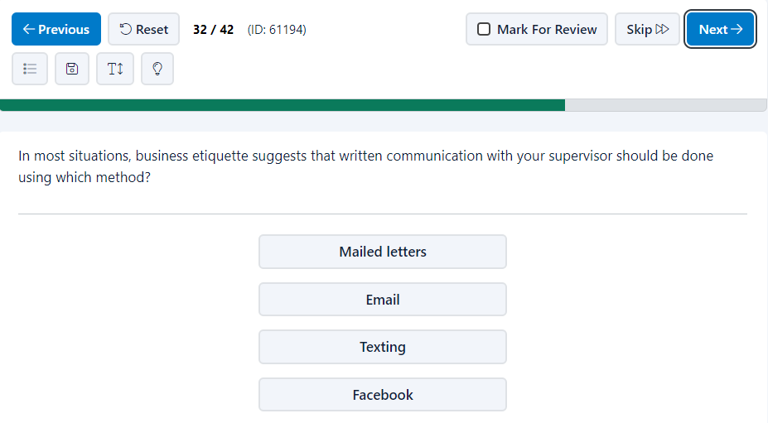
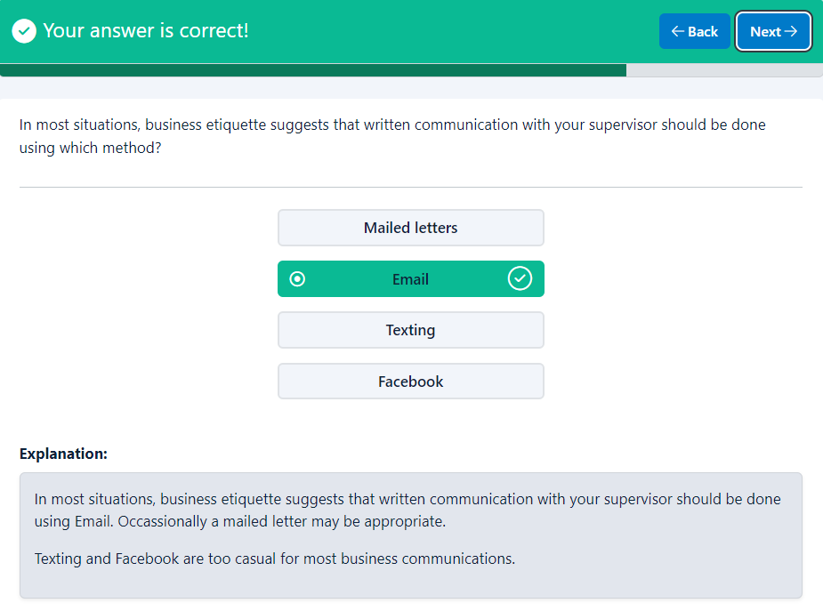
Your answer is correct!
BackNext
In most situations, business etiquette suggests that written communication with your supervisor should be done using which method?

- Mailed letters
- Email
- Texting
- Facebook
Explanation
Explanation:
In most situations, business etiquette suggests that written communication with your supervisor should be done using Email. Occassionally a mailed letter may be appropriate.
Texting and Facebook are too casual for most business communications.

End of page
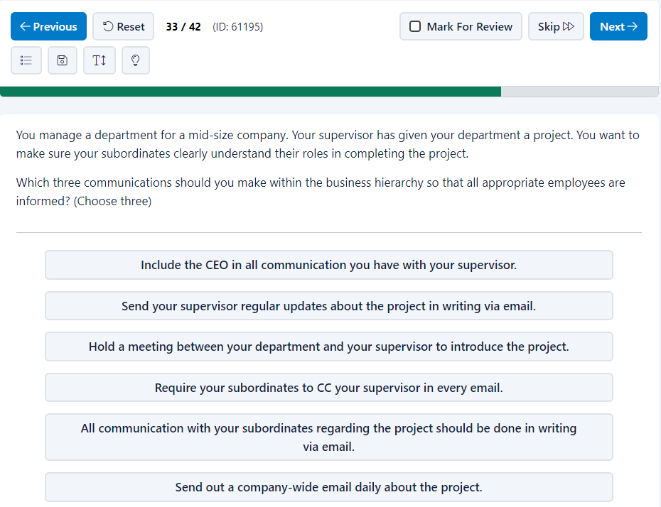
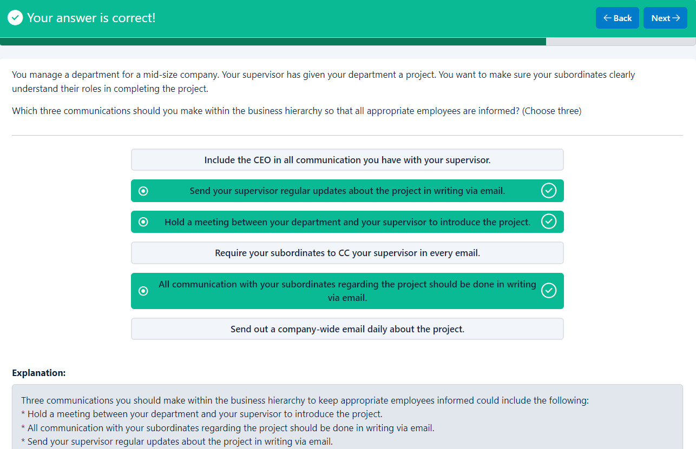
Your answer is correct!
BackNext
You manage a department for a mid-size company. Your supervisor has given your department a project. You want to make sure your subordinates clearly understand their roles in completing the project.
Which three communications should you make within the business hierarchy so that all appropriate employees are informed? (Choose three)

- Include the CEO in all communication you have with your supervisor.
- Send your supervisor regular updates about the project in writing via email.
- Hold a meeting between your department and your supervisor to introduce the project.
- Require your subordinates to CC your supervisor in every email.
- All communication with your subordinates regarding the project should be done in writing via email.
- Send out a company-wide email daily about the project.
Explanation
Explanation:
Three communications you should make within the business hierarchy to keep appropriate employees informed could include the following:
* Hold a meeting between your department and your supervisor to introduce the project.
* All communication with your subordinates regarding the project should be done in writing via email.
* Send your supervisor regular updates about the project in writing via email.

End of page
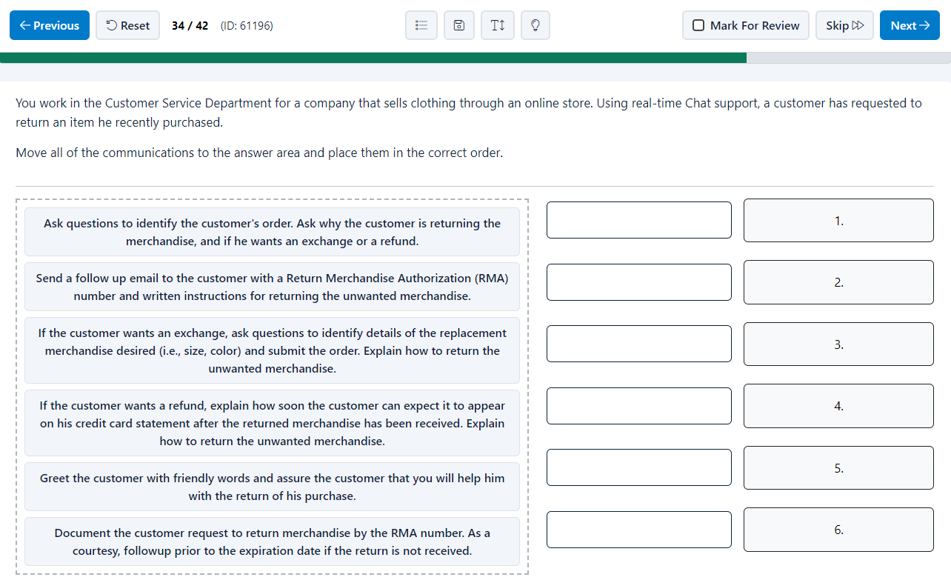
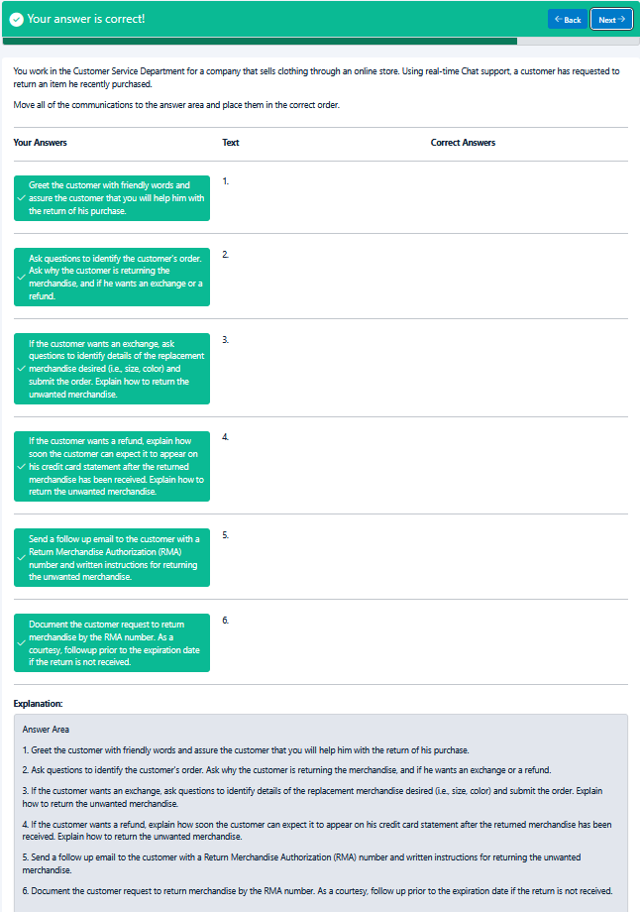
Your answer is correct!
BackNext
You work in the Customer Service Department for a company that sells clothing through an online store. Using real-time Chat support, a customer has requested to return an item he recently purchased.
Move all of the communications to the answer area and place them in the correct order.

Your Answers
Text
Correct Answers

Greet the customer with friendly words and assure the customer that you will help him with the return of his purchase.
1.

Ask questions to identify the customer's order. Ask why the customer is returning the merchandise, and if he wants an exchange or a refund.
2.

If the customer wants an exchange, ask questions to identify details of the replacement merchandise desired (i.e., size, color) and submit the order. Explain how to return the unwanted merchandise.
3.

If the customer wants a refund, explain how soon the customer can expect it to appear on his credit card statement after the returned merchandise has been received. Explain how to return the unwanted merchandise.
4.

Send a follow up email to the customer with a Return Merchandise Authorization (RMA) number and written instructions for returning the unwanted merchandise.
5.

Document the customer request to return merchandise by the RMA number. As a courtesy, followup prior to the expiration date if the return is not received.
6.

Explanation
Explanation:
Answer Area
1. Greet the customer with friendly words and assure the customer that you will help him with the return of his purchase.
2. Ask questions to identify the customer's order. Ask why the customer is returning the merchandise, and if he wants an exchange or a refund.
3. If the customer wants an exchange, ask questions to identify details of the replacement merchandise desired (i.e., size, color) and submit the order. Explain how to return the unwanted merchandise.
4. If the customer wants a refund, explain how soon the customer can expect it to appear on his credit card statement after the returned merchandise has been received. Explain how to return the unwanted merchandise.
5. Send a follow up email to the customer with a Return Merchandise Authorization (RMA) number and written instructions for returning the unwanted merchandise.
6. Document the customer request to return merchandise by the RMA number. As a courtesy, follow up prior to the expiration date if the return is not received.

End of page
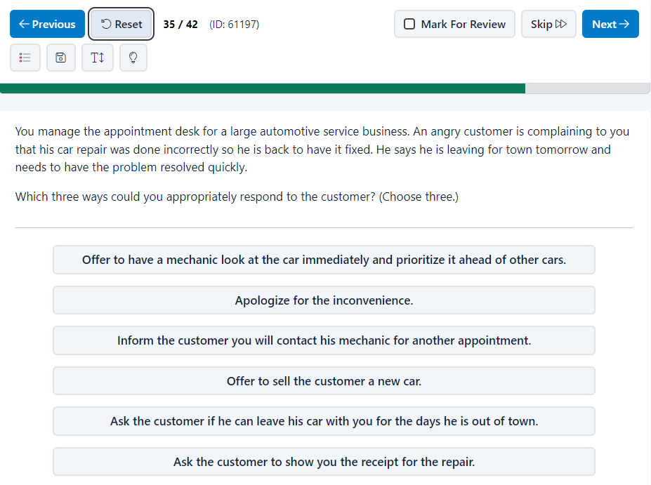
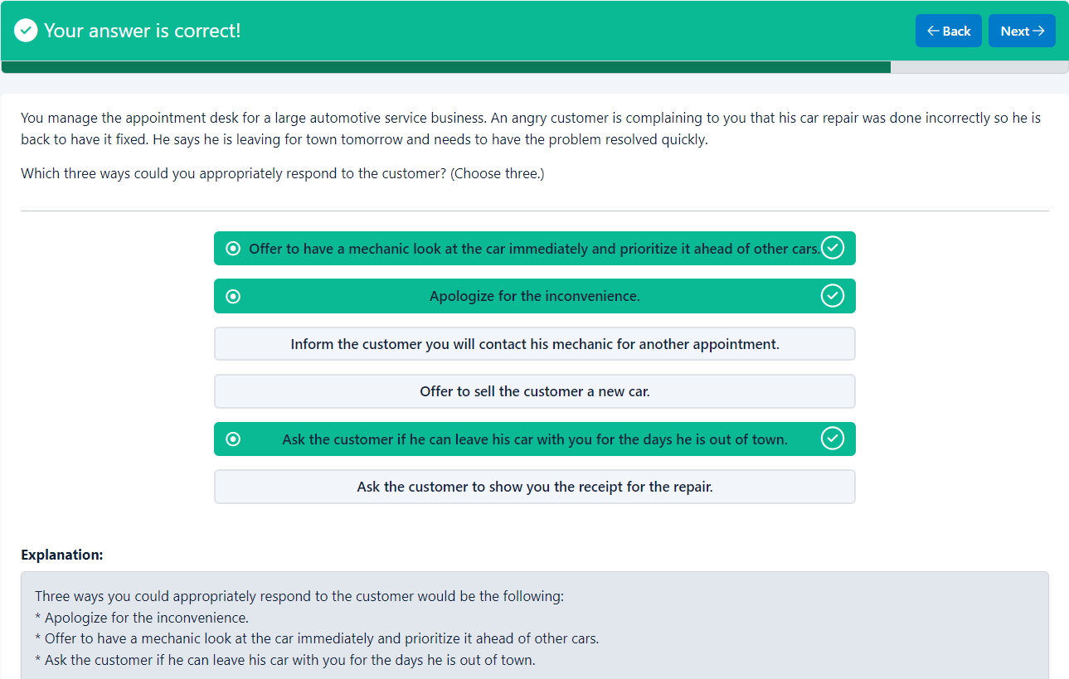
Your answer is correct!
BackNext
You manage the appointment desk for a large automotive service business. An angry customer is complaining to you that his car repair was done incorrectly so he is back to have it fixed. He says he is leaving for town tomorrow and needs to have the problem resolved quickly.
Which three ways could you appropriately respond to the customer? (Choose three.)

- Offer to have a mechanic look at the car immediately and prioritize it ahead of other cars.
- Apologize for the inconvenience.
- Inform the customer you will contact his mechanic for another appointment.
- Offer to sell the customer a new car.
- Ask the customer if he can leave his car with you for the days he is out of town.
- Ask the customer to show you the receipt for the repair.
Explanation
Explanation:
Three ways you could appropriately respond to the customer would be the following:
* Apologize for the inconvenience.
* Offer to have a mechanic look at the car immediately and prioritize it ahead of other cars.
* Ask the customer if he can leave his car with you for the days he is out of town.

End of page
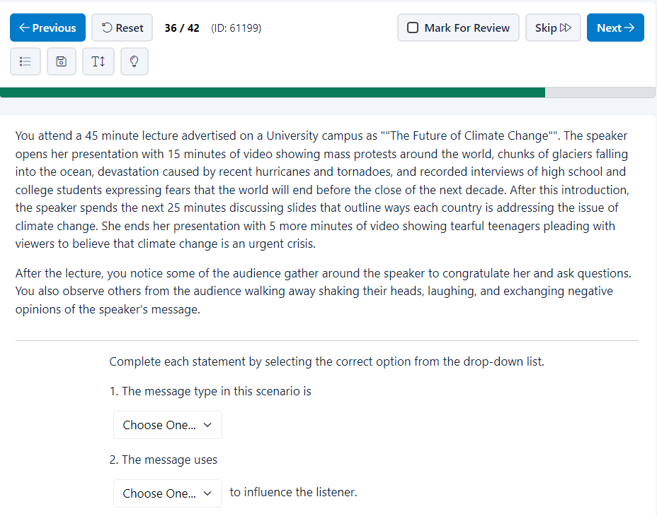
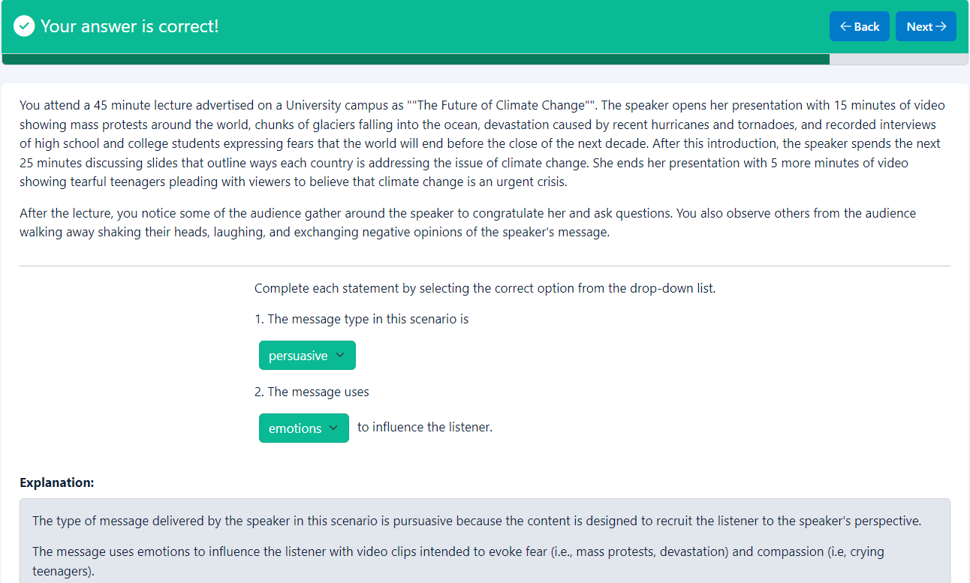
Your answer is correct!
BackNext
You attend a 45 minute lecture advertised on a University campus as ""The Future of Climate Change"". The speaker opens her presentation with 15 minutes of video showing mass protests around the world, chunks of glaciers falling into the ocean, devastation caused by recent hurricanes and tornadoes, and recorded interviews of high school and college students expressing fears that the world will end before the close of the next decade. After this introduction, the speaker spends the next 25 minutes discussing slides that outline ways each country is addressing the issue of climate change. She ends her presentation with 5 more minutes of video showing tearful teenagers pleading with viewers to believe that climate change is an urgent crisis.
After the lecture, you notice some of the audience gather around the speaker to congratulate her and ask questions. You also observe others from the audience walking away shaking their heads, laughing, and exchanging negative opinions of the speaker's message.

Complete each statement by selecting the correct option from the drop-down list.
1. The message type in this scenario is
Choose One...informativepersuasivemotivationalcorrectional
2. The message uses
Choose One...ethicsemotionslogicculture to influence the listener.
Explanation
Explanation:
The type of message delivered by the speaker in this scenario is pursuasive because the content is designed to recruit the listener to the speaker's perspective.
The message uses emotions to influence the listener with video clips intended to evoke fear (i.e., mass protests, devastation) and compassion (i.e, crying teenagers).

End of page
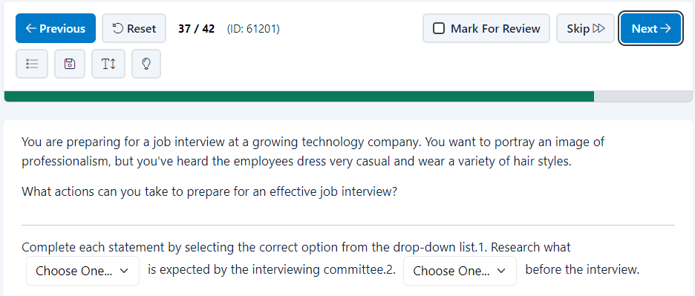
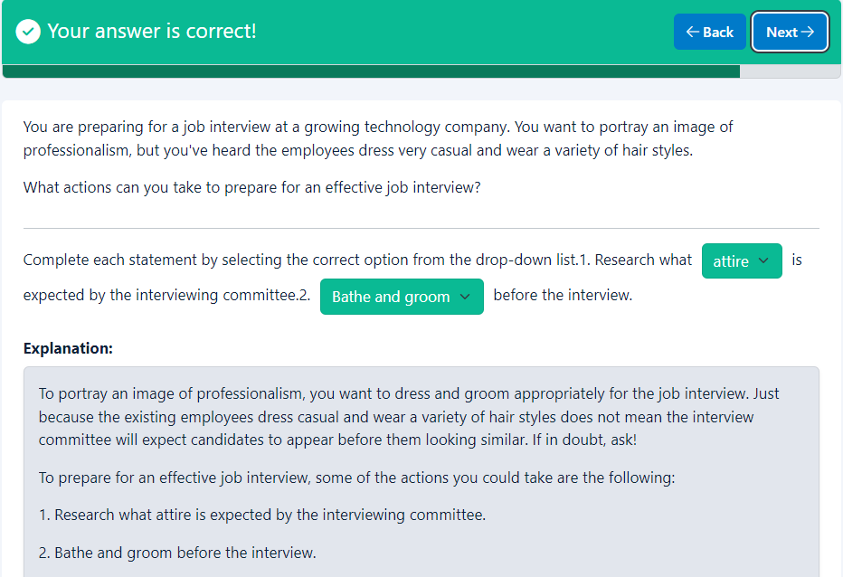
Your answer is correct!
BackNext
You are preparing for a job interview at a growing technology company. You want to portray an image of professionalism, but you've heard the employees dress very casual and wear a variety of hair styles.
What actions can you take to prepare for an effective job interview?

Complete each statement by selecting the correct option from the drop-down list.1. Research what Choose One...racegendereducationattire is expected by the interviewing committee.2. Choose One...Eat lunchCall to say youBathe and groomBuy a new car" before the interview.
Explanation
Explanation:
To portray an image of professionalism, you want to dress and groom appropriately for the job interview. Just because the existing employees dress casual and wear a variety of hair styles does not mean the interview committee will expect candidates to appear before them looking similar. If in doubt, ask!
To prepare for an effective job interview, some of the actions you could take are the following:
1. Research what attire is expected by the interviewing committee.
2. Bathe and groom before the interview.

End of page


Your answer is correct!
BackNext
Select the image that is the best example of the design principle known as, Contrast.

- 
- 
- 
- 
Explanation
Explanation:
The design principle of Contrast communicates focus to the viewer. This is usually emphasized by making one element "stand out" from the other elements of an image by changing its color, or brightness, or sharpness. In these examples, the correct image shows one element as yellow while the others are all white. This communicates that the one is different or unique.

End of page
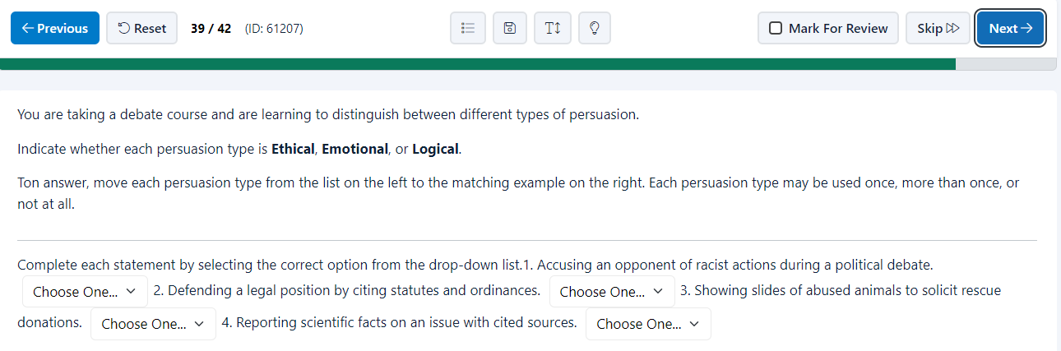
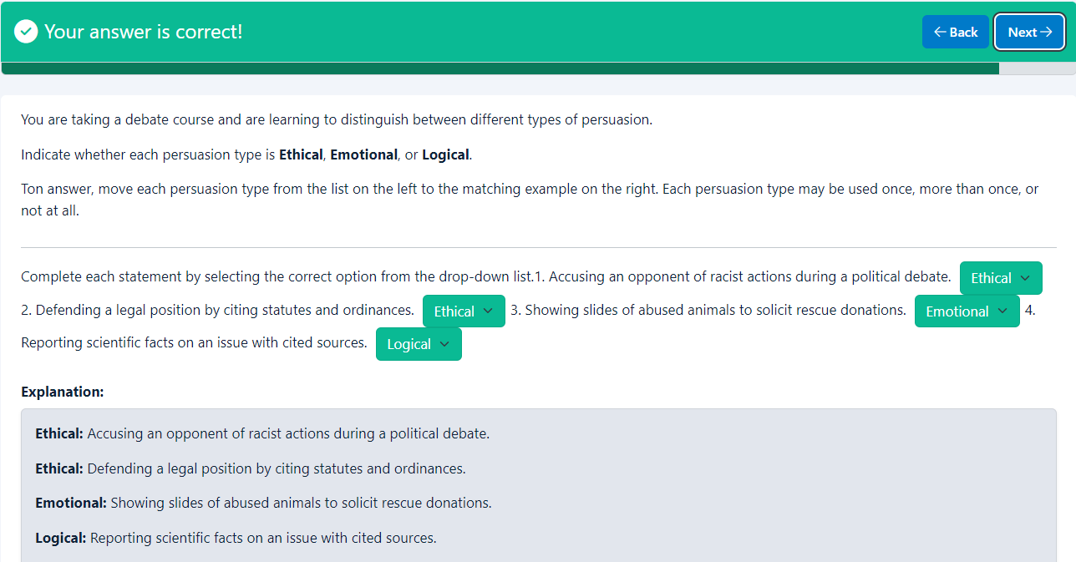
Your answer is correct!
BackNext
You are taking a debate course and are learning to distinguish between different types of persuasion.
Indicate whether each persuasion type is Ethical, Emotional, or Logical.
Ton answer, move each persuasion type from the list on the left to the matching example on the right. Each persuasion type may be used once, more than once, or not at all.

Complete each statement by selecting the correct option from the drop-down list.1. Accusing an opponent of racist actions during a political debate. Choose One...EthicalLogical2. Defending a legal position by citing statutes and ordinances. Choose One...EthicalEmotional3. Showing slides of abused animals to solicit rescue donations. Choose One...EmotionalEthical4. Reporting scientific facts on an issue with cited sources. Choose One...LogicalEthical
Explanation
Explanation:
Ethical: Accusing an opponent of racist actions during a political debate.
Ethical: Defending a legal position by citing statutes and ordinances.
Emotional: Showing slides of abused animals to solicit rescue donations.
Logical: Reporting scientific facts on an issue with cited sources.

End of page
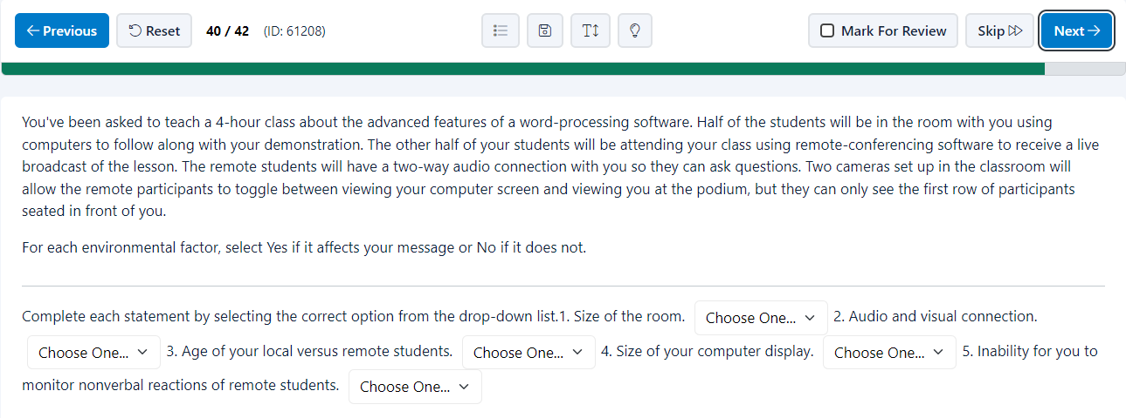
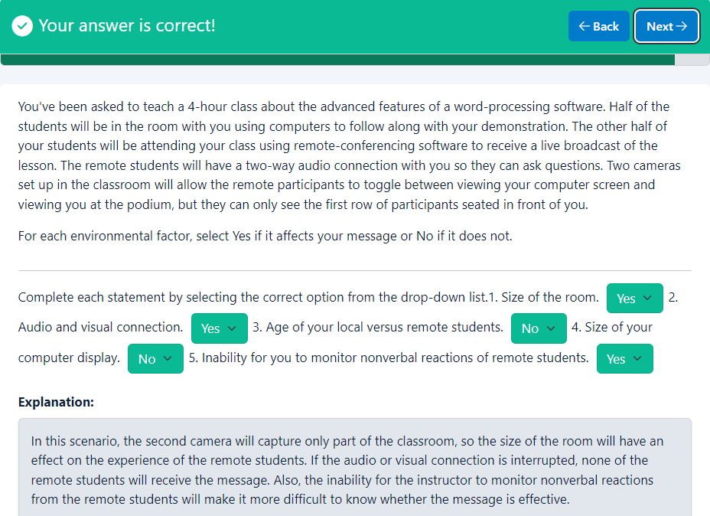
Your answer is correct!
BackNext
You've been asked to teach a 4-hour class about the advanced features of a word-processing software. Half of the students will be in the room with you using computers to follow along with your demonstration. The other half of your students will be attending your class using remote-conferencing software to receive a live broadcast of the lesson. The remote students will have a two-way audio connection with you so they can ask questions. Two cameras set up in the classroom will allow the remote participants to toggle between viewing your computer screen and viewing you at the podium, but they can only see the first row of participants seated in front of you.
For each environmental factor, select Yes if it affects your message or No if it does not.

Complete each statement by selecting the correct option from the drop-down list.1. Size of the room. Choose One...YesNo2. Audio and visual connection. Choose One...YesNo3. Age of your local versus remote students. Choose One...YesNo4. Size of your computer display. Choose One...YesNo5. Inability for you to monitor nonverbal reactions of remote students. Choose One...YesNo
Explanation
Explanation:
In this scenario, the second camera will capture only part of the classroom, so the size of the room will have an effect on the experience of the remote students. If the audio or visual connection is interrupted, none of the remote students will receive the message. Also, the inability for the instructor to monitor nonverbal reactions from the remote students will make it more difficult to know whether the message is effective.

End of page
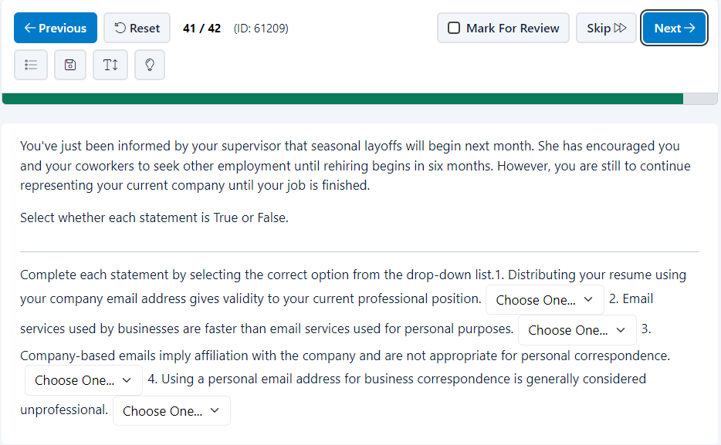
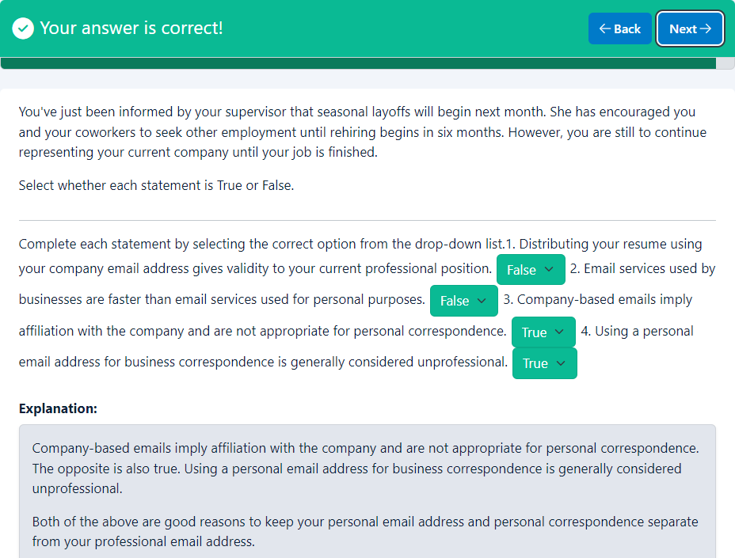
Your answer is correct!
BackNext
You've just been informed by your supervisor that seasonal layoffs will begin next month. She has encouraged you and your coworkers to seek other employment until rehiring begins in six months. However, you are still to continue representing your current company until your job is finished.
Select whether each statement is True or False.

Complete each statement by selecting the correct option from the drop-down list.1. Distributing your resume using your company email address gives validity to your current professional position.Choose One...TrueFalse2. Email services used by businesses are faster than email services used for personal purposes.Choose One...TrueFalse3. Company-based emails imply affiliation with the company and are not appropriate for personal correspondence.Choose One...TrueFalse4. Using a personal email address for business correspondence is generally considered unprofessional.Choose One...TrueFalse
Explanation
Explanation:
Company-based emails imply affiliation with the company and are not appropriate for personal correspondence. The opposite is also true. Using a personal email address for business correspondence is generally considered unprofessional.
Both of the above are good reasons to keep your personal email address and personal correspondence separate from your professional email address.

End of page
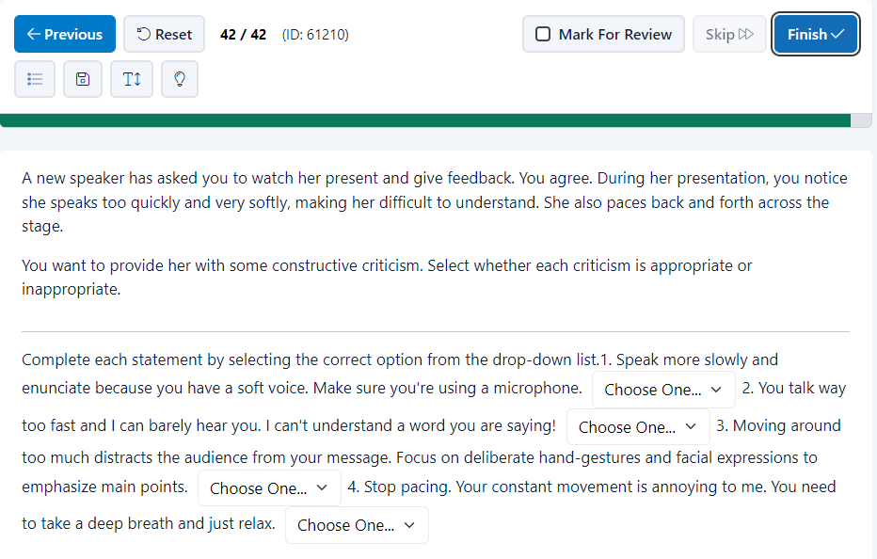
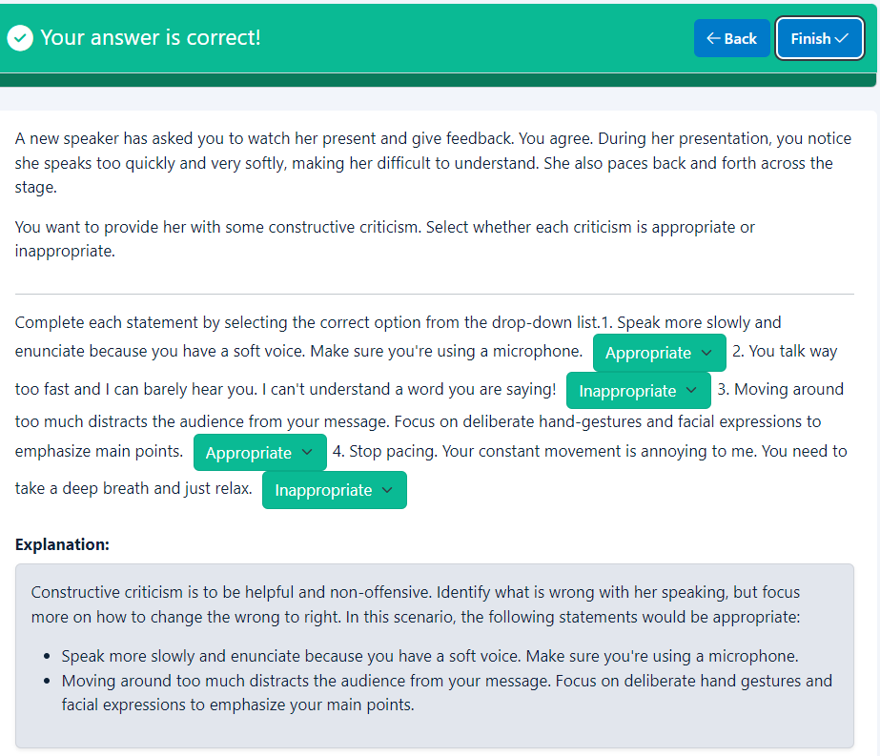
Your answer is correct!
BackFinish
A new speaker has asked you to watch her present and give feedback. You agree. During her presentation, you notice she speaks too quickly and very softly, making her difficult to understand. She also paces back and forth across the stage.
You want to provide her with some constructive criticism. Select whether each criticism is appropriate or inappropriate.

Complete each statement by selecting the correct option from the drop-down list.1. Speak more slowly and enunciate because you have a soft voice. Make sure you're using a microphone. Choose One...AppropriateInappropriate2. You talk way too fast and I can barely hear you. I can't understand a word you are saying! Choose One...AppropriateInappropriate3. Moving around too much distracts the audience from your message. Focus on deliberate hand-gestures and facial expressions to emphasize main points. Choose One...AppropriateInappropriate4. Stop pacing. Your constant movement is annoying to me. You need to take a deep breath and just relax. Choose One...AppropriateInappropriate
Explanation
Explanation:
Constructive criticism is to be helpful and non-offensive. Identify what is wrong with her speaking, but focus more on how to change the wrong to right. In this scenario, the following statements would be appropriate:
- Speak more slowly and enunciate because you have a soft voice. Make sure you're using a microphone.
- Moving around too much distracts the audience from your message. Focus on deliberate hand gestures and facial expressions to emphasize your main points.

End of page

